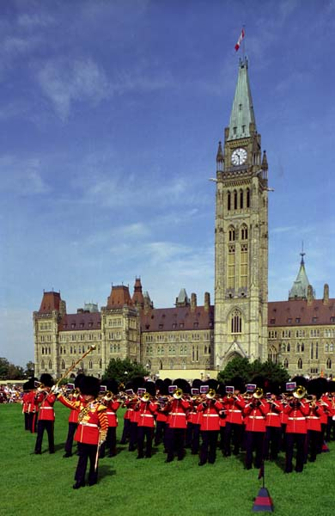
Ottawa 2016
Wednesday June 15th, 2016
7:00am Leave Superior
12:00pm Bag Lunch (no stores)
5:00pm – 6:00pm Check in Algonquin College Residence
6:00pm – 7:00pm Supper around College area
7:00pm – 9:00pm Campus tour, Fitness, Canadian Trivia brush-up

Thursday June 16th, 2016
8:00am – 9:00am Breakfast @ residence
9:30am – 11:45am War Museum
12:00pm – 12:45pm Lunch @ Byward Market
Scenic Sussex Drive Excursion
1:00pm – 2:30pm Canada Aviation Museum
3:00pm – 4:30pm Museum of Agriculture
5:00pm-8:30pm Supper @ Saint-Lawrence Centre and an evening of shopping
9:00pm Residence
10:00pm In rooms…lights out at 10:30pm

Friday June 17th, 2016
8:00am – 9:00am Breakfast @ residence
9:30am – 11:00am Museum of Nature
11:30am – 12:15pm Lunch - Eaton’s Center
12:30pm – 1:30pm Rideau Canal – Tutorial and Visit
2:00pm – 3:30pm Walking tour of monuments on Parliament Hill
3:30pm – 6:00pm Supper and Tour the Byward Market
6:10pm/6:30pm/6:35pm Parliamentary Tour
9:00pm Back to residence
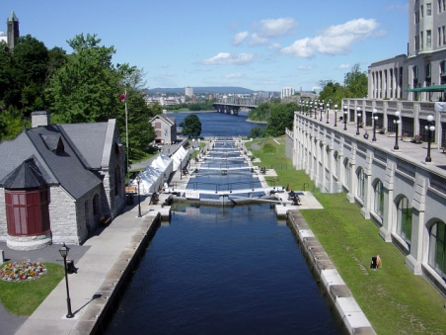
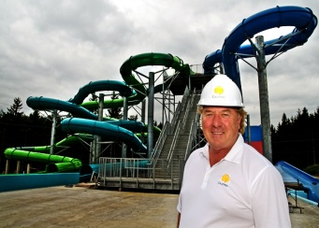
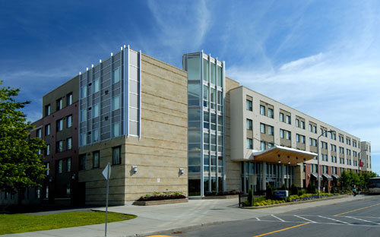

Saturday June 18th, 2016
7:30am – 8:30am Breakfast @ residence
9:00am – 12:00pm Canadian Museum of History
12:15pm – 1:30pm Lunch in Hull, QUE
2:00pm – 6:00pm Calypso water park and supper
6:00pm – 8:00pm Back in residence – reflective writing assignment
8:00pm – 9:00pm Pack – ready for morning

Sunday June 19th, 2016
6:30am – 7:00am Breakfast @ residence
7:00am Departure
6:00 pm Approximate arrival time in Bathurst

