Name: ________________________________
You will research a topic in oceanography or marine biology. You will be creating a display for our Marine Museum. To begin this project, you will need to demonstrate your research skills. To begin google “museum exhibits” images. Take some time to look at the images. (About 10 mins) Find three that interest you and fill out the form below. (Please print a copy of the completed sheet to hand into me at the end of class)

Step 1: Find three examples of museums exhibits on line.
Exhibit 1: ______________________________________________________
What is this exhibit about? _____________________________________________________________________
Which elements did you find the most interesting?
- ______________________________________________________
- ______________________________________________________
- ______________________________________________________

Exhibit 2: ______________________________________________________
What is this exhibit about? _____________________________________________________________________
Which elements did you find the most interesting?
- ______________________________________________________
- ______________________________________________________
- ______________________________________________________

Exhibit 3: ______________________________________________________
What is this exhibit about? _____________________________________________________________________
Which elements did you find the most interesting?
- ______________________________________________________
- ______________________________________________________
- ______________________________________________________
You will be creating an exhibit for our museum. Please start researching which area of our Marine Museum you would like to focus on. Marine Museums can include
- Ocean life
- Natural phenomenon
- Ocean problems and/or disasters
- Science and Technology related to ocean or ocean environments
- Other marine or ocean themes
Please begin by choosing three areas you would like to explore
- ________________________________________________________
- ________________________________________________________
- ________________________________________________________

Begin with Topic 1 : _____________________________________________
Do a quick internet search and find three websites about your topic. Write the name of the website on the left and write 5 notes on the right that you found on the website. If you cannot find 5 notes on the website, this website is not an acceptable research tool and you will need to find a different website.
Website 1 |  | 1  2  3  4  5
Website 2 |  | 1  2  3  4  5
Website 3 |  | 1  2  3  4  5

Begin with Topic 2 : _____________________________________________
Do a quick internet search and find three websites about your topic. Write the name of the website on the left and write 5 notes on the right that you found on the website. If you cannot find 5 notes on the website, this website is not an acceptable research tool and you will need to find a different website.
Website 1 |  | 1  2  3  4  5
Website 2 |  | 1  2  3  4  5
Website 3 |  | 1  2  3  4  5

Begin with Topic 3 : _____________________________________________
Do a quick internet search and find three websites about your topic. Write the name of the website on the left and write 5 notes on the right that you found on the website. If you cannot find 5 notes on the website, this website is not an acceptable research tool and you will need to find a different website.
Website 1 |  | 1  2  3  4  5
Website 2 |  | 1  2  3  4  5
Website 3 |  | 1  2  3  4  5

After reviewing your basic research. Choose an area you would like to focus on. Search exhibits, dioramas, posters and other visual aids in your area of study on the internet. Fill in the following form

My chosen area is : _________________________________________________

Brainstorming Ideas (Include quick sketches or pictures of what you would like to include and the general information you will be including.

Display | Information
Name: _________________________________________________________
Topic and Title __________________________________________________
Section of the Museum: ___________________________________________
Plan (Include measurements, sketches, materials, information)
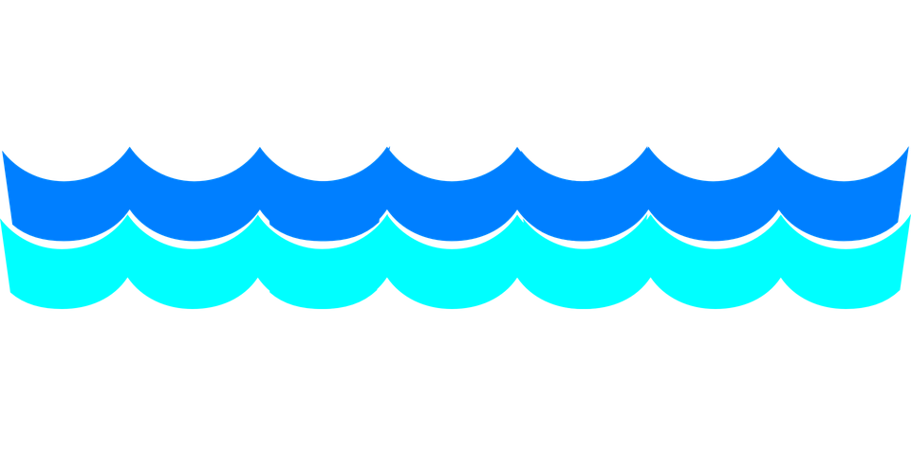
Include all additional information, drafts, and plans on additional paper.

