Student Conference
By
_____________________________

- Name your favorite reading piece (novel, poem, magazine, etc.) from SMS. What was it about? Why did you enjoy it?

- Name 3 things you learned in Science this term? Tell your adult about how you’re doing with your group quiz and individual quizzes.

- Tell your adult about something you’ve learned in health class this term.

- Think about math. What strengths have you identified in math? What do you need more practice in?

- Show your adult your First Nations Oral Traditions project. Tell them about it.

- Show your adult your character analysis. Tell them about the novel, “The Absolutely True Diary of a Part-Time Indian”, and Arnold Spirit. What did you learn about the treatment of First Nations people at the time of the novel?

NOW… think about you’re learning habits. Explain to your adult whether or not you are meeting these expectations. Be specific as to why you feel you’ve got it, or you’re not there yet. Give yourself suggestions for improvement.

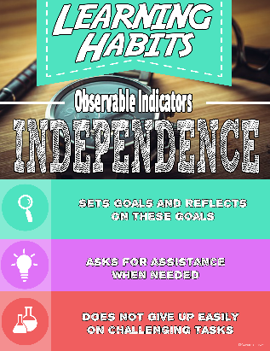
Got it!

Not there yet.
____________________________________________________________________________________________________________________________________________________________________________________________________________________________________________________________________________
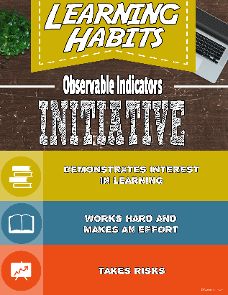
Got it!

Not there yet.
____________________________________________________________________________________________________________________________________________________________________________________________________________________________________________________________________________

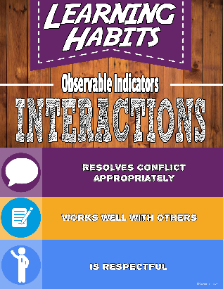
Got it!

Not there yet.
____________________________________________________________________________________________________________________________________________________________________________________________________________________________________________________________________________

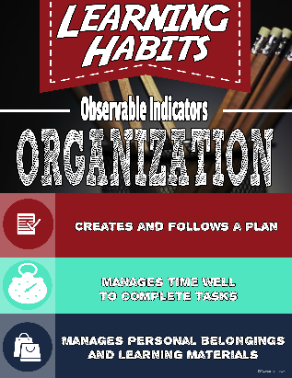
Got it!

Not there yet.
____________________________________________________________________________________________________________________________________________________________________________________________________________________________________________________________________________

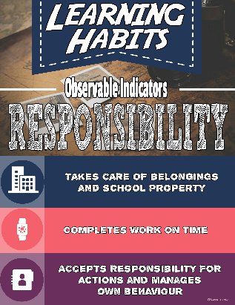
Got it!

Not there yet.
____________________________________________________________________________________________________________________________________________________________________________________________________________________________________________________________________________

