Grade Level Tasks
Outcome SS4
Develop and apply formulas for determining the volume of right prisms and right cylinders.

Building Block: Students can determine the volume of a given right prism or right cylinder given the area of the base.
- Math Makes Sense: the textbook is a great resource to find example questions that can be used with students. Below are some examples to get you started:
  - Math Makes Sense Grade 8, page 198: #4
  - Math Makes Sense Grade 8, page 205: #4
  - Math Makes Sense Grade 8, page 218: #4
- Below are some websites that deal with volume.
  - http://illuminations.nctm.org/Activity.aspx?id=4095
  - http://www.interactivestuff.org/sums4fun/3dboxes.html
  - http://www.learner.org/interactives/geometry/area_volume.html
- What happens to the volume of a rectangular prism when the area of its base is doubled? Use an example in your explanation.
- A triangular prism has a volume of 128 cm³. Its height is 8 cm. What is the area of its base?
- Explain the connection between the area of the base of a right 3-D object and the formula for the volume of the object.
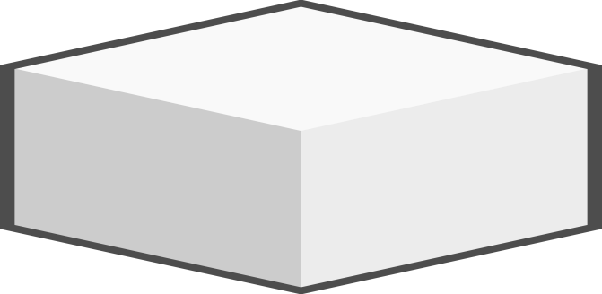
- What could be the volume of the right rectangular prism below? Prove your answer.
2.4cm²
4.8cm²
Building Block: Students can demonstrate that the orientation of a given 3-D object does not affect its volume.
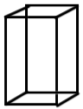
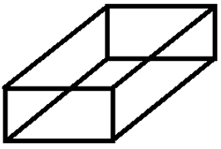
- Which right rectangular prisms have the same volume as the one below?
8cm
100 cm
30cm
8cm
30cm
100 cm
  - c.
10cm
8 cm
30 cm
100 cm
30cm
9cm
- Compare the volume of the following cylinders. Fill in the blank with >, < or =

Building Block: Students can apply a formula to solve a given problem involving volume of a right cylinder or a right prism.
- A certain cube has the side length of 4 cm. What is the volume of the cube?
- Find the volume of the triangular prism below.
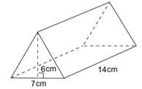
- Find the volume of a rectangular prism measuring 5 m by 9 m by 4 m.
- Which of the following is the volume of the cylinder if the height is 15 cm and the diameter is 8 cm?
  - 3014.4 cm³
  - 753.6 cm³
  - 200.96 cm³
  - 50.24 cm³
- Draw two different right rectangular prisms that both have a volume of 2400 cm³.
- Which cylinder would hold more water? Explain your answer.
Cylinder A: height 7.0 cm, diameter 5.0 cm
Cylinder B: height 5.0 cm, diameter 7.0 cm
- A cube has a volume of 96cm³. What are its dimensions?
- A hockey puck is a solid piece of rubber with a diameter of 10 cm and a height of 2.5 cm. How many hockey pucks can fit inside a cylindrical container with a volume of 1.1 m³?

