Readiness Tasks
Outcome 8SS4
Develop and apply formulas for determining the volume of right prisms and right cylinders.
Readiness Goal: Develop and apply a formula for determining the area of rectangles and the volume of right rectangular prisms (6SS3)
- Write a formula for area that will work for any rectangle, including squares. Explain how it works.

- Use a formula to calculate the volume of the figure shown. Show your work.
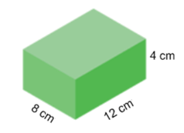

- Find the area of each rectangle. What do you notice?
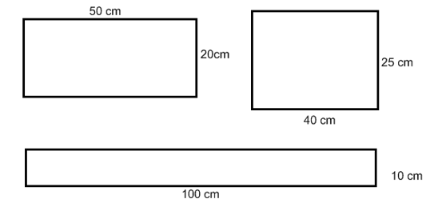
How is the formula for the area of these two shapes the same? How is it different?

- Jacob has 36m of fencing to go around his dog’s play area. Sketch all the possible rectangle-shaped pens he could build. Find the area of each choice. Which pen will give his dog the most room?

- A rectangular prism has a volume of 600 cm³. It has a base that has a length of 10 cm and a width of 4 cm. What is the height of the rectangular prism? How do you know? Show your thinking.

- Stephen wants to carpet the floor in the playroom. Carpet is sold by the m². How much carpet will he need?
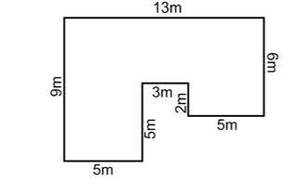

Readiness Goal: Demonstrate an understanding of volume (5SS3)
- What is the volume of the object below?
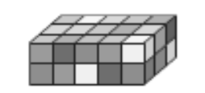
  - 10 cm³
  - 15 cm³
  - 22 cm³
  - 30 cm³

- Use linking cubes to build as many rectangular prisms as you can that have a volume of 36 cubic units.
- Jason’s family is building a new pool that is 5 m long and has a volume of 30 m3. What are the dimensions of the pool?
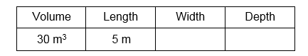

Using the same volume and length, design a pool that would have a different width and depth.

- Tim’s pencil case is 9 cm long, 4 cm high and 5 cm wide. Laurie’s pencil case is 10 cm long, 6 cm high and 3 cm wide. Who’s pencil case has a greater volume? Explain your thinking.

- Looking at a Kleenex box, explain your strategy for estimating the volume. Using cubes, calculate the most accurate volume of the Kleenex box. How reasonable was your estimate.

