**Grade Level Tasks**

**Outcome SS5**

Draw and interpret top, front and side views of 3-D objects composed of right rectangular prisms.

1. Math Makes Sense: the textbook is a great resource to find example questions that can be used with students. Below are some examples to get you started:  
   1. Math Makes Sense Grade 8, page 439: #8, 9, 10
   2. Math Makes Sense Grade 8, page 445: #4, 7, 8
2. Below are some websites that deal with 3-D objects.  
   1. <http://pbskids.org/cyberchase/math-games/point-out-view/>
3. Match the front, top, right side, and left side views to the lettered views below.  
     
   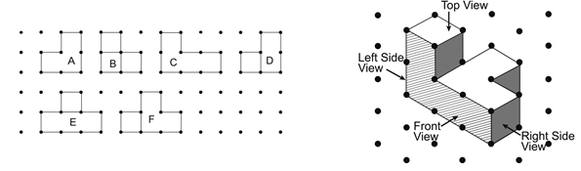

1. Which isometric drawing is a rotation of the figure below?  
     
     
     
     
     
     
   1.  c.
   2. d.

1. Use square dot paper. Sketch the front, top, and side views of this object.  
     
   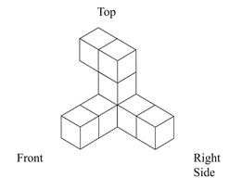

1. 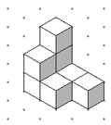Which of the following below could be the **top view** of the figure below?

* 1. 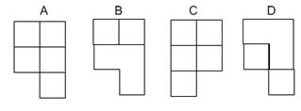 c.
  2. d.

1. 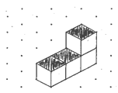Build and rotate this building horizontally 90o clockwise. Draw the building in its new position on isometric dot paper. Continue to rotate the building 90o and draw each new position. How many different drawings can be made?  
     
     
     
     
     
     
     
     
     
     
   Repeat the steps above performing the rotations *vertically* 90° towards you.Compare your results.

**Building Block:** Students can draw and label a 3-D object on isometric dot paper given the top, front and side views.

1. Grade Level Resources located on the portal:  
   1. **Isometric Drawings Dot Paper**: a simple placemat that can be placed in a sheet protector when students are required to draw isometric.
2. Below are some websites that deal with 3-D objects.  
   1. <http://nlvm.usu.edu/en/nav/frames_asid_195_g_3_t_3.html?open=activities&from=category_g_3_t_3.html>
   2. <http://passyworldofmathematics.com/isometric-drawing-and-3d-cubes/>
   3. <http://www.teacherled.com/resources/isodraw/isoshapeload.html>
   4. <http://nzmaths.co.nz/ao/gm4-6-relate-three-dimensional-models-two-dimensional-representations-and-vice-versa>
   5. <http://incompetech.com/graphpaper/isometricdots/>
3. Using the top, front and side views, draw the 3D object on isometric paper.  
     
    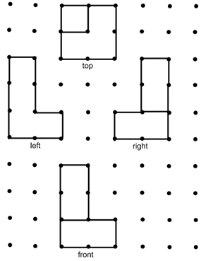
4. Using the top, front and side views, draw the 3D object on isometric paper.  
     
     
    