Readiness Tasks
Outcome 8SS5
Draw and interpret top, front and side views of 3-D objects composed of right rectangular prisms.

- Draw the image of quadrilateral ABCD after it has been rotated 90° counterclockwise about point C, and then translated 4 units down and 5 units right. (6SS6)
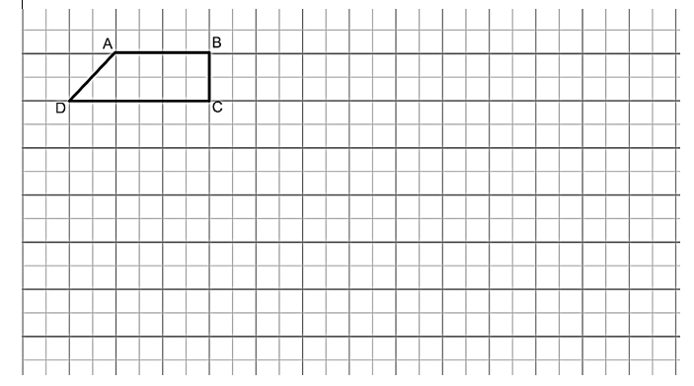
- Describe the two transformations that resulted in image A”B”C.
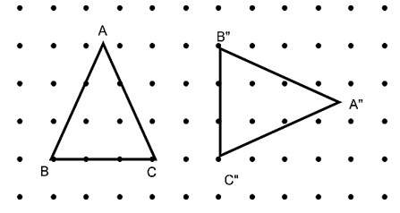
- Draw the image of shape XYZ after it has been rotated 90° clockwise about point Z and then rotated 90°counter clockwise about point Y’. (6SS6)
- Describe the two transformations that resulted in image A”B”C”. (6SS6)
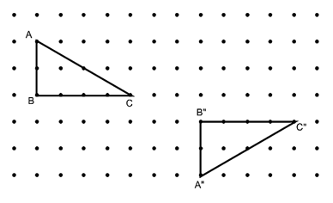
- Rotate PQR 180º clockwise around point P to create P’Q’R’. (7SS5)
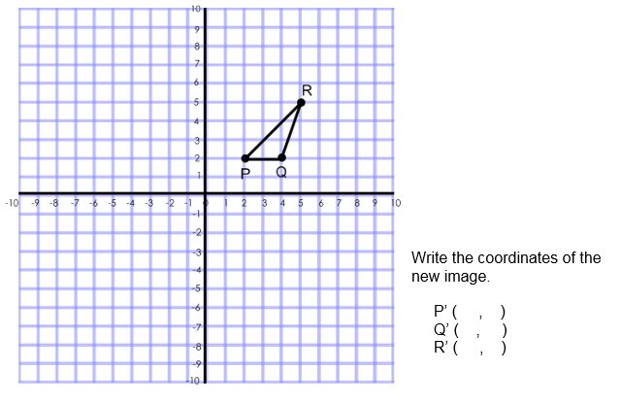
- Plot the following points on a Cartesian grid: (7SS5)
A (-4,1), B (-6,3), C (-5,6), D (-3,6), E (-2,3)
Rotate the image 90° clockwise about the origin. Write the coordinates of the new image.

