https://www.cbc.ca/player/play/903984707796
https://www.youtube.com/watch?v=ABbcACI-EG4
http://bataille.ccbn-nbc.gc.ca/en/bataille-des-plaines-d-abraham/les-deux-armees-face-a-face/les-forces-en-presence.php
https://www.britishbattles.com/french-indian-war/battle-of-quebec-1759/
http://www.uppercanadahistory.ca/wm/wm8.html

DIRECTIONS FOR BUILDING A POPSICLE STICK LAUNCHER…Cause you can’t have muskets!
Step 1 – Paint two of the craft sticks the colour, of your country (England or France) if you wish.
Step 2 – Using a glue gun, glue two popsicle sticks together. Then glue the other two together. We are doing this for two reasons. First, it makes the structure stronger. Second, the end of the handle becomes an anchor point for the rubber band while loading the Launcher.
Step 3 – Choose which is going to be the handle and which is going to be the crossbar. Place the crossbar about 1/4 of the way from the top of the handle and glue in place.
Step 4 – Make sure your crossbar is on the bottom (so you have the smooth surface of the handle on top). Now glue your buttons on the crossbar about 2 cm in from the ends.
Step 5 – Cut your straw about 6 – 8 cm in length should work.
Step 6 – Glue the piece of straw on top of the handle so it is above the crossbar near the front. Let the glue set for a few minutes.
Step 7 – Wrap the rubber band around the end of the crossbar on one side, then repeat on the other side. Pull the long side of the rubber band and anchor it on the end of the handle. Your Launcher is now ready for action!

USING THE CRAFT STICK LAUNCHER
To use the launcher place a Q-Tip cotton swab in the end of the straw. Carefully lift the rubber band off the end of the handle and pinch the Q-Tip and elastic between your index finger and thumb. Pull back until the Q-Tip end is just inside the straw. Make sure your other fingers are out of the way, and then LET GO!

Pro Tip! Design your launchers with various lengths of straws (experiment). The longer straws will allow great pull on the rubber band, resulting in launches covering greater distances, but they also require more finger strength. Test it out to find the optimal design for the best launches!
Pro Tip 2! The cotton swabs may get a little fuzzy which can cause friction and cause issues during launching. If this happens, you have two options. Roll the ends of the Q-Tip between slightly moistened fingers to help tighten up the fibers. Or you can wrap a little clear tape around the ends of the Q-Tip to keep things neat and moving smoothly through the straw, just make sure it is really smooth so the tape doesn’t cause friction.

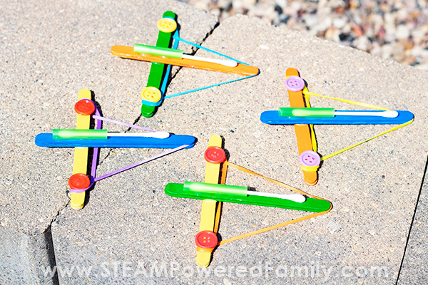

Tricorn hat!

STEP 1

Draw the outline shape for your hat. This is just freehand but if you need you can find lots of template online.

STEP 2

Decorate your hat with glue and glitter paint. Consider making one part of the hat with colours or markings from your country. Let dry.

STEP 3

When dry hold two pieces of the hat back to back and staple the edges.

STEP 4

Go around the hat stapling the sides of the hat together. You can make it smaller or larger at this point to fit your head. Do not staple your head!

STEP 5

Try on your new tricorn hat and have fun and try not to get shot!

