**Grade Level Tasks**

**Outcome SS1**

Develop and apply the Pythagorean Theorem to solve problems.

1. Which side of the triangle is the hypotenuse? How do you know?

A

B

C

1. Find the area of the third square.  
   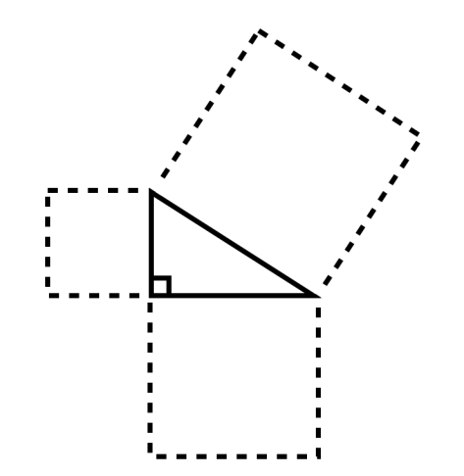

120cm2

83cm2

1. What is the length of the missing side?

12 cm

16 cm

* 1. 4 cm b. 10.6 cm c. 20 cm d. 112 cm

1. Explain how you know that the following statement is false.

r2

p2

q2

*The Pythagorean relationship in the triangle can be written as:*

*r2 + p2 = q2*

1. What is the area of the missing square?  
   

25 m2

16 m2

* 1. 3m2 b. 9m2 c. 16m2 d.41m2

1. Find the length of the hypotenuse.

4cm

12cm

1. Find the length of the missing leg.

10cm

9cm

1. Erin placed a ladder against the side of a house. The ladder was 1.6m from the base of the wall and reached 3.4m up the wall. What is the length of the ladder?

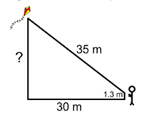

1. What is the height of the kite above the ground?
2. How long is the ladder in the drawing below?  
   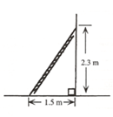
3. For safety reasons, a construction company established the following rule: when placing a ladder against the side of a building, the distance of the base of the ladder from the wall should be at least $\frac{1}{3}$ of the length of the ladder. Can an 8m ladder reach a window that is 7.75 m above ground when this rule is followed?
4. A high school swimming pool has the dimensions shown below. While the swimming coach walks along the edge of the pool from A to B to C, a swimmer swims diagonally from A directly to C. How much farther does the coach travel?

18 m

7 m

B

C

D

A

1. What is the length of the missing leg?  
     
   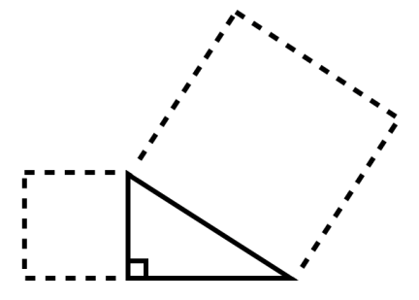

25 m2

5 m2

1. A right triangle has legs that are 3 m and 7 m in length. How long is the hypotenuse?
2. Johanna just bought a big screen TV. It has a diagonal measure of 60 inches. What might be the dimensions of the television?
3. Two jets left an airport at the same time. One travelled east at 700 km/h while the other travelled south at 800 km/h. How far apart were the jets at the end of an hour?
4. The mast of a ship is 8 m tall. A rope is stretched 13 meters from the top of the mast to a cleat on the deck of the ship. How far is the cleat from the base of the mast?
5. A rectangle has an area of 24 cm2. How long might the diagonal of the rectangle be?
6. A rope is stretched from the top of a 7 foot tent pole to a point on the ground 12 feet from the base of the pole. How long is the rope?

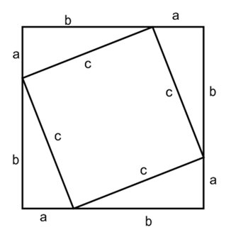

1. If “a” is equal to 2 m and “b” is equal to 5 m, what is the perimeter of both squares?

1. You’ve just picked up a ground ball at first base and you see an opposing player running towards third base. If the perimeter of the square infield is 109.72m, how far will you have to throw the ball to get it from first base to third?
2. What is the perimeter of the rectangle below?  
     
   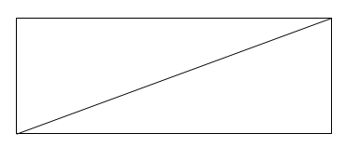

28 m

53 m

1. Find the perimeter of the trapezium WXYZ given that:

WX = 7cm  
YZ = 13cm  
ZW = 8cm

Z

Y

X

W

1. Using square tiles, show how you can determine whether or not a triangle is a right angle triangle.
2. Is the triangle below a right triangle? Explain how you know.

14 cm

9 cm

8 cm

1. Which of these two triangles is a right triangle? Explain your thinking.

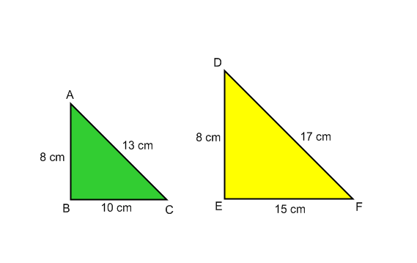

1. Show how you know that 5, 12, 13 is a Pythagorean triple.
2. Is 5, 8, 9 a Pythagorean triple? Explain your thinking.
3. A 5 m ladder leans against a house. It is 3 m away from the base of the house. How high does the ladder reach?
4. Rocco walks diagonally across a room. If the dimensions of the room are 4 m by 3 m, how many times will Rocco need to walk diagonally across the room to walk 100 m?
5. Find the perimeter of the triangle ABC.  
     
   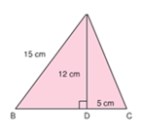
6. Luke is about to ride a straight water slide. The launching platform is at the top of a tower that is 12 m tall. The splash pool at the end of the slide is 16 m from the base of the tower. How long is the water slide itself?