**Grade Level Tasks**

**Outcome 8SS2/8SS3**

(8SS2) Draw and construct nets for 3-D objects.  
(8SS3) Determine the surface area of: right rectangular prisms, right triangular prisms and right cylinders to solve problems.

1. Math Makes Sense: the textbook is a great resource to find example questions that can be used with students. Below are some examples to get you started:  
   1. Math Makes Sense 8, page 180: #3, 5
2. Which of the following nets will not result in a cube?  
     
   1. c.
   2. d.
3. Match the net to the shape it represents.
   1. 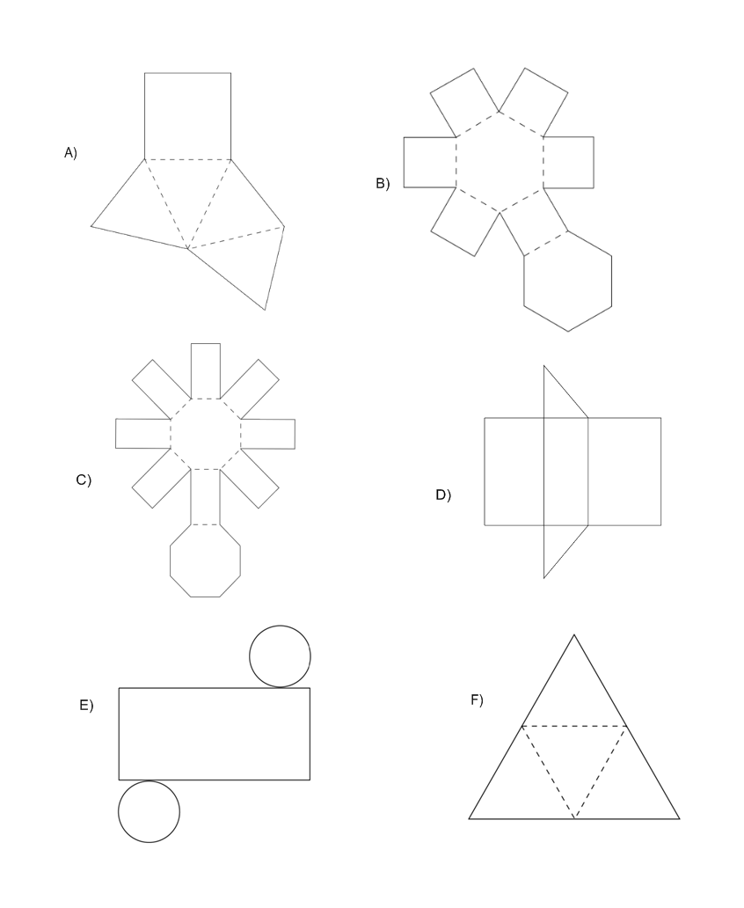hexagonal prism
   2. square pyramid
   3. right cylinder
   4. triangular pyramid
   5. octagonal prism



1. Predict if this is a net. If so, describe the shape by naming its faces and the number of vertices. If it is not a net, what changes would you make for it to become a net?
2. The figure below is a net that has been cut into two pieces. How can the pieces be combined to form the net of a cube.

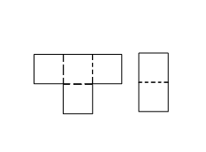

**Building Block:** Students can draw nets for a given right circular cylinder, right rectangular prism, and right triangular prism, and verify by constructing (8SS2).

1. Math Makes Sense: the textbook is a great resource to find example questions that can be used with students. Below are some examples to get you started:  
   1. Math Makes Sense 8, pages 176: “Reflect” question
   2. Math Makes Sense 8, pages 182: #13
2. Get the following 3-D objects from your teacher and trace each face to create the net for your object.  
   1. Rectangular prism c. Cylinder
   2. Triangular Prism d. Square pyramid
3. Draw the net for this triangular prism on the grid below. Name each face.

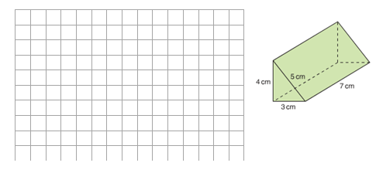

1. Draw the net for the container below. Label the measurements on the net.

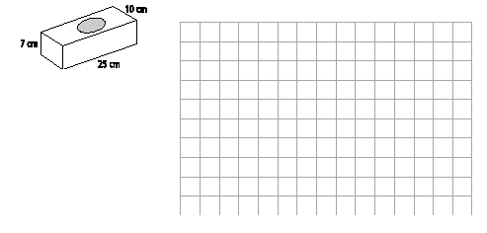

1. Draw two different nets for the following objects and identify faces using letters. Indicate which sides have the same length. How many additional nets are possible? Justify your answer.  
     
     
     
    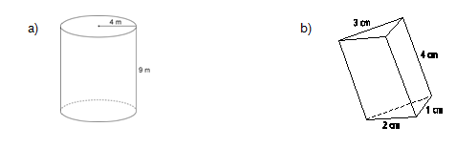 
2. Draw a net for each object described below.  
   1. a cylinder 5 cm in diameter and 12 cm high
   2. a rectangular prism 3 cm by 4 cm by 6 cm
   3. a cube with a side length of 5 cm

**Building Block:** Students can identify all the faces of given cylinders and prisms, including right rectangular and right triangular prisms (8SS3).

1. Math Makes Sense: the textbook is a great resource to find example questions that can be used with students. Below are some examples to get you started:  
   1. Math Makes Sense 8, pages 193: #15
2. On the net of the given 3-D object, find the area of each face.

4 cm

9 cm

1. For the given rectangular prism, draw the net and identify all congruent faces.

6 cm

13 cm

9 cm

1. 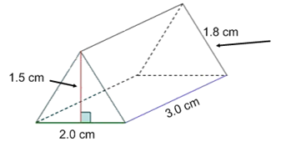Find the missing dimension on the net of the given triangular prism.

**Building Block:** Students can describe and apply strategies for determining surface area of a given right rectangular or right triangular prism and a given right cylinder.  
  
 Students can explain, using examples, the relationship between the area of 2-D shapes and the surface area of a given 3-D object (8SS3).

1. Math Makes Sense: the textbook is a great resource to find example questions that can be used with students. Below are some examples to get you started:  
   1. Math Makes Sense 8, pages 191: #4
2. 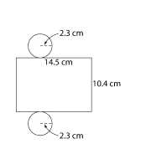Determine the surface area of the cylinder.
3. One square on a cube has an area of 4 cm2. What is the surface area of the cube? Show how you got your answer.
4. The rectangular prism below has a surface area of 250cm2. What is the area of the shaded sided?

A = 72 m2

A = 36 m2

**Building Block:** Students can solve problems involving surface area (8SS3).

1. Grade Level Tasks Located on the portal:
2. **Printable Nets**: Spectrum offers a great selection of [plastic polydrons](https://spectrum-nasco.ca/catalogsearch.htm?Action=Display&Search=POLYDRON&PLPG=ECCDEM%20-%20POLYDRON) that can really help students visualize nets and work with the surface area of 3D shapes. However, printable nets can also be cut out and given to students to help them with this concept.
3. **Surface Area and Volume cards**: question sets that can be used to practice this concept. (NOTE: THESE ARE NOT TO SCALE)
4. **Surface Area and Volume placemats**: instead of using the cards, these placemats can be a little less time consuming for the teacher to prepare and still allow for differentiation.
5. What is the surface area of the prism?  
     
     
   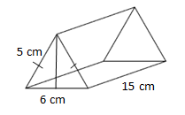
6. An object shaped like a cube with cylinder drilled through the middle is to be painted. The cube has an edge length of 28cm and the hole has a diameter of 16 cm. What is the area of the object that will need painted?  
     
     
    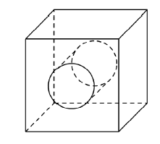
7. The diagram below shows 3 balls closed in a cylindrical container. Each ball has a diameter of 13 cm. Find the surface area of the container.  
     
    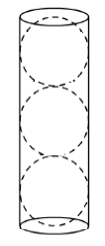
8. Two of the faces on a rectangular prism have areas of 32cm2 and 48cm2. Draw and label the rectangular prism, then find its surface area.
9. Find the surface area of a small cylindrical garbage can without a lid. The height is 28 cm and diameter is 18 cm.
10. An aluminum company produces two different sizes of juice cans. One has a diameter of 6 cm and a height of 10 cm. The second can has a diameter of 4 cm and a height of 15 cm. Which can requires the most aluminum to produce? Show how you know.
11. Kaitlyn and Joey each bought a tube of candy. Both containers cost the same amount. Which container is made of more plastic?   
      
      
    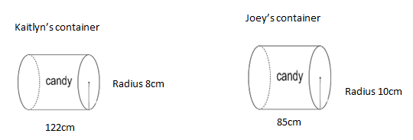
12. A cylindrical CD case has surface area of 1025.0 cm2. Each CD is 0.1 cm thick and 11.0 cm in diameter. How many CDs can the case hold? Explain what you did to solve the problem.
13. A right rectangular prism has a square base with area 16m2. The surface area of the prism is 96 m2. What are the dimensions of the prism?
14. Pete is painting the walls and ceiling of his room, which is 4 m long, 3.6 m wide, and 2.9 m high. The window is 60 cm long by 40 cm wide. The door is 1.2 m high by 85 cm long. Determine the surface area of the walls to be painted. If each can of paint covers 22 m2, how many cans of paint will be needed to paint the room?