**Readiness Tasks**

**Outcome 8SS2/8SS3**

(8SS2) Draw and construct nets for 3-D objects.  
(8SS3) Determine the surface area of: right rectangular prisms, right triangular prisms and right cylinders to solve problems.



1. Calculate the area of the circle

10 cm

* 1. 31.4 cm2
  2. 314 cm2
  3. 100 cm2
  4. 125.6 cm2

**Possible question prompts:**

* + 1. *What information do you need to calculate the area of a circle?*
    2. *What is the formula to calculate the area of a circle?*
    3. *What information about the circle do you already know?*

1. TSN wants to add a logo on the two buttons of the curling sheet for their tournament. Each “button” is 30 cm in diameter. How much paint, in cm2, is needed? Show all your work.

**Possible question Prompt:**

* + 1. *What formula do you need to use in order to solve this question?*
    2. What information about the circle do you already know?

1. Daniel just bought a used sailboat with two sails that need replacing.  
     
   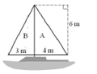  
   1. How much sail fabric will Daniel need if he replaces sail A?
   2. How much sail fabric will Daniel need if he replaces sail B?

**Possible Question Prompt:**

* + 1. *What is the formula for finding the area of sale A?*
    2. *Can you demonstrate how to apply the formula?*

1. Find the area of the triangle.  
     
     
     
     
     
   1. 32.5 mm2
   2. 32 mm2
   3. 227.5 mm2
   4. 65 mm2

**Possible Question Prompt:**

* + 1. *What is the formula do you need to use in order to solve this question?*
    2. *What information about the triangle do you already know?*
    3. *Is there information in the question that is irrelevant?*

1. Explain, using pictures and/or words, how you would estimate the area of the following triangle.

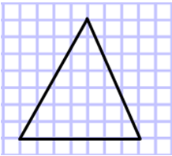

**Possible Question Prompt:**

1. *Do we need to apply a certain formula?*
2. *How is the grid useful?*

1. Show, using pictures and words, how the area of a rectangle can be used to find the area of a triangle.  
     
     
   **Possible Question Prompts:**
   * 1. *What connection can be formed between the two shapes?*
2. What is the area of the following triangle?  
     
   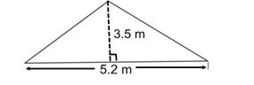  
     
     
   **Possible Question Prompts:**
3. *Which formula can be applied to solve the problem?*
4. *Is all necessary information given to solve the problem?*

1. How would you calculate the area of the green ring below? Show your thinking.  
     
   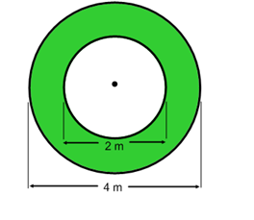  
     
   **Possible Question Prompts:**
   * 1. *What formula(s) is necessary to solve this problem?*
     2. *Is the area of the white circle relevant?*
     3. Is all necessary information given to solve the problem?
2. Joshua has a pizza with a diameter of 12 cm. He wants to know the circumference of the pizza. How could you explain to Joshua how he could find the circumference? What is the circumference of the pizza?

**Possible question prompts:**

* + 1. *Will knowing the diameter help in finding the circumference?*
    2. *What do we know about circumference?*
    3. *Is all necessary information given in the question?*

1. Calculate the circumference of each circle.

5cm

8cm

15cm

**Possible question Prompt:**

* + 1. *What formula do you need to use in order to solve this question?*
    2. *Is there enough information to answer the questions?*

1. Find the area of the following figures:  
   1. 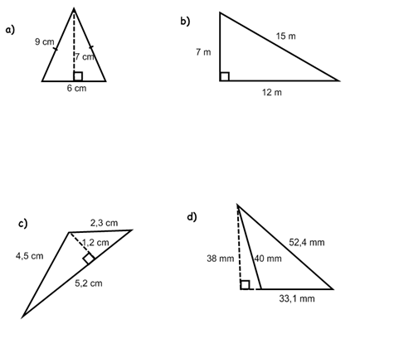 c.



* 1.  d.

**Possible Question Prompt:**

* + 1. *What is the formula do you need to use in order to solve this question?*
    2. *Is there additional/unnecessary information given?*

**Readiness Goal:** Demonstrate an understanding of circles (7SS1)

1. Math Makes Sense: the textbook is a great resource to find example questions that can be used with students. Below are some examples to get you started:  
   1. Math Makes Sense Grade 7, page 131-132: #4
   2. Math Makes Sense Grade 7, page 137: #5
2. The circumference of a circle is 37**.**68 cm. What is the **radius** of the circle?  
   1. 6.14 cm
   2. 12 cm
   3. 6 cm
   4. 18.84 cm

**Possible Question Prompts:**

* + 1. *What information is necessary to find the radius?*
    2. *What is the formula needed to solve this question?*
    3. *How can you adjust the formula to find the radius?*

1. Complete the following chart about a circle’s radius, diameter, circumference and area.

|  |  |  |  |  |
| --- | --- | --- | --- | --- |
|  | **Diameter** | **Radius** | **Circumference** | **Area** |
| **Circle #1** | 10 cm |  |  |  |
| **Circle #2** |  | 30 cm |  |  |
| **Circle #3** | 21 cm |  |  |  |
| **Circle #4** |  | 18 cm |  |  |

**Possible Question Prompts:**

* + 1. *What is the formula(s) needed to complete the chart?*
    2. *How does knowing the diameter help in completing the remainder of the chart?*

1. Estimate how many strokes it would take Kim to swim around the edge of a circular pool, if it took her 25 strokes to swim across the widest part of the pool?

**Possible Question Prompts:**

* + 1. *What information is needed to answer the question?*
    2. *Would a diagram help in finding a solution?*
    3. *What is the significance of the “widest” part of the pool?*

1. What is the best *estimate* for the circumference of a circle with a *diameter* of 12 cm? Justify your choice.  
   1. 6 cm
   2. 18 cm
   3. 36 cm
   4. 48 cm

**Possible Question Prompts:**

* + 1. *What formula would you use in order to calculate diameter?*
    2. *Which part of that formula would you use to help out your estimation?*

1. 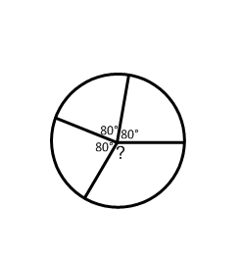Three of the four central angles of a circle are congruent and each measures 80°. What is the measure of the fourth central angle? Explain your thinking.

**Possible Question Prompts:**

* + 1. *What is the angle measure of a circle?*

1. Construct a circle with a diameter of 10 cm. Find and label the radius, the diameter, and the circumference of the circle.

**Possible Question Prompts:**

* + 1. *What is the formula needed to solve this problem?*
    2. What information is required? What information is required?

1. A manufacturing company is making dinner plates with a diameter of 30 cm. It wants to add a gold border around the outside of each dinner plate. How much gold border would be necessary for a set of 8 plates? Explain your thinking.

**Possible Question Prompts:**

* + 1. *What are you trying to solve for?*
    2. *What is the formula needed to solve the question?*

**Readiness Goal:** Develop and apply a formula for determining the area of rectangles (6SS3).

1. Find the area of each rectangle. What do you notice?

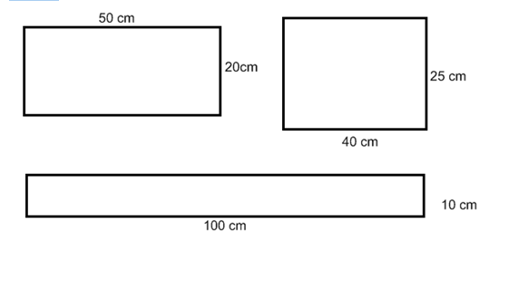

**Possible Question Prompts:**

* + 1. *What is the formula to find perimeter/Area?*
    2. *Do the units of measure differ from perimeter to Area?*

1. 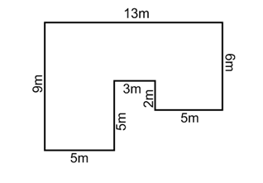 Stephen wants to carpet the floor in the playroom. Carpet is sold by the m2. How much carpet will he need?

**Possible Question Prompts:**

* + 1. *What are you being asked to calculate?*
    2. *What is the formula being used?*
    3. *What strategies can you use to help solve the question?*

1. The perimeter of a rectangle is 20 cm. What could the area of this rectangle be?

**Possible question prompts:**

2. A rectangle has a perimeter of 26 cm and a side length of 4 cm. What is the area of this rectangle?

**Possible question prompts:**

2. The perimeter of a square is 24 m. What is the area?

**Possible question prompts:**

2. The perimeter of a rectangle is 30 cm and its area is 150 cm2. Find the dimensions of this rectangle.

**Possible question prompts:**

2. What is the area of the shaded rectangle, if both shapes have the same perimeter?

5 m

5 m

12 cm

7 cm

**Possible question prompts:**

|  |  |  |  |  |  |  |  |  |  |
| --- | --- | --- | --- | --- | --- | --- | --- | --- | --- |
|  |  |  |  |  |  |  |  |  |  |
|  |  |  |  |  |  |  |  |  |  |
|  |  |  |  |  |  |  |  |  |  |
|  |  |  |  |  |  |  |  |  |  |
|  |  |  |  |  |  |  |  |  |  |
|  |  |  |  |  |  |  |  |  |  |
|  |  |  |  |  |  |  |  |  |  |
|  |  |  |  |  |  |  |  |  |  |

1. Draw a rectangle on the grid with a length of 7 units and a width of 4 units. Determine the area of the rectangle. Explain your thinking.

**Possible Question Prompts:**

1. *How is the grid helpful in determining area?*
2. *What are the appropriate units to show in your answer?*

**Readiness Goal:** Perfect Squares and Square Roots: students can apply their knowledge of perfect squares and square roots in order to work with the volume of right prisms.

1. See 8N1 document for this.