Grade Level Tasks
Outcome SP2
Solve problems involving the probability of independent.
Using Grade Level Tasks
As you guide your students through the learning of SP2, you will be noting evidence of where students are in their learning. The included tasks may assist you in determining which students need clarification and/or further experiences with specific concepts and/or skills.
Assessment information will be gathered via observations, conversations, and work products. Tasks can be used in class for discovery, practice and/or formative assessment purposes. The tasks can be used as warm-ups, for journaling, as exit slips, to revisit past learning, and so on. They can be modified to meet student needs with the goal of increasing student learning with respect to this outcome.
Formative information on your students’ learning should be recorded on the spreadsheet Grade Level Formative Data Collection.
The following tasks are organized by Outcome Building Block.

Building Block: Determine the theoretical and experimental probability of a given outcome involving two independent events.
- Math Makes Sense: the textbook is a great resource to find example questions that can be used with students. Below are some examples to get you started:
  - Math Makes Sense 8, page 411
  - Math Makes Sense 8, page 420: questions 4-6
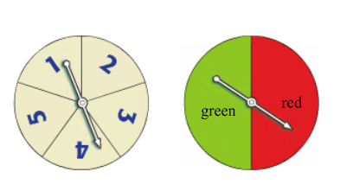
- Robert spins the pointer on each spinner. Find the probability of each event.
  - Red and 5
  - Green and an odd number
  - Red and a prime number
- What is the probability of spinning red on the spinner below and rolling a composite number?
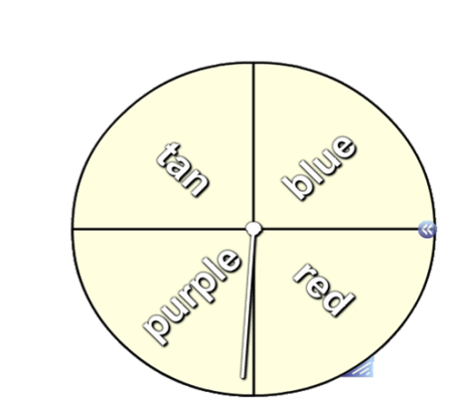
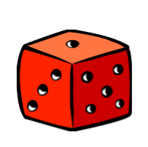
  - $\frac{1}{12}$
  - $\frac{1}{6}$
  - $\frac{1}{4}$
  - $\frac{2}{6}$

- A marble is removed from Container 1. Then a marble is removed from Container 2.
What is the probability of the first marble being red and the second marble being black.
Taken from: http://www.nelson.com/mathfocus/grade8/quizzes/ch10/mf8_ch._10_lesson_3try.htm
- Allison is out to eat with her parents. She has an option of 5 different drinks (soda, coffee, tea, water, juice), 2 main courses (chicken, steak), and 3 sides (rice, green beans, and potatoe). How many different combinations are possible?
  - 30
  - 20
  - 10
  - 100
Taken from: http://www.thatquiz.org/tq/previewtest?R/Q/A/M/39811327719630
- You flip a coin 4 times. What is the probability that you get 2 heads and 2 tails? Write down the sample space and the event set to determine the probability of this event.
Taken from: http://everythingmaths.co.za/grade-11/10-probability
Building Block: Solve a given probability problem involving two independent events.
- Math Makes Sense: the textbook is a great resource to find example questions that can be used with students. Below are some examples to get you started:
  - Math Makes Sense 8, pages 413: “Reflect” question
  - Math Makes Sense 8, pages 420-422: questions 7-16, “Reflect” question at the bottom of the page
- Imagine that you have boarded an airplane. The rows are numbered from 1 to 25, and there are four seats per row, two on each side of the aisle. Seats in each row are labeled A through D. Answer the following questions:
  - What is the probability of sitting in row number 7?
  - What is the probability of sitting in a window seat?
  - What is the probability of sitting in an “A” seat?
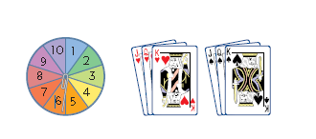
- Joey spins the spinner and then draws a card from those shown.
  - Explain why the spin and the draw are independent events.
  - Determine P(1, Jack)
  - Determine P(even number, King)
  - Determine P(multiple of 5, black card).
- A single die is rolled. From a deck of cards, 1 card is randomly selected.
  - How many possible outcomes are there?
  - What is the probability of selecting the ace of diamonds and rolling a 3?
  - What is the probability of selecting an ace of any suit and rolling a 1?
  - What is the probability of selecting a spade and rolling an odd number?
  - What is the probability of selecting a face card and rolling a 5 or a 6?

- Henry, Toshi, Lizette, Anna, and Vance were all scheduled to give oral reports in their history class on Tuesday. However, when the class met, the teacher announced that only two people would give their presentations that day. To determine which two, all of their names were placed in a hat and two names were drawn out. What is the probability that Henry and Anna were the names picked to give presentations? Show how you arrived at your conclusion.
Taken from: http://www.edu.gov.on.ca/eng/studentsuccess/lms/files/tips4rm/gr8unit6.pdf
- Claire has two bags of coloured cubes, one marked A and the other marked B. In bag A, there are 3 yellow and 4 green cubes. In bag B, there are 2 blue and 5 red cubes. Without looking, Claire picks one cube from bag A and then one cube from bag B. Answer the questions below based on this information. Assume that after each part all cubes are replaced in their appropriate bag.
  - What is the question if the answer is $\frac{8}{49}$?
  - What is the question, if the answer is 0?
  - What is the question, if the answer is $\frac{3}{7}$?
- A randomly-thrown dart hits the dartboard shown. Find the probability of the dart landing in the shaded region.
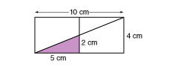
Taken from: http://www.glencoe.com/sec/math/studytools/cgi-bin/msgQuiz.php4?isbn=1-57039-850-X&chapter=10&lesson=2

Building Block: Distinguish between dependent and independent events.
- Decide whether the following events are dependent or independent and explain your thinking.
  - Mrs. Brown’s first child was a boy and her second child will also be a boy.
  - Kelly swam 2 hours every day for the last ten months and her swimming times improved.
- Give examples of two independent and two dependent events. Explain your thinking.
- Angela flips a coin and lands on tails. Then she rolls a die and rolls a 3. Are these two events dependent or independent? Explain.
Taken from: http://www.nelson.com/mathfocus/grade8/quizzes/ch10/mf8_ch._10_lesson_1try.htm
- Brad has 3 white shirts, 4 blue shirts, and 2 red shirts in his closet. On Monday he pulls out a blue shirt. On Tuesday he pulls out another blue shirt. Are these two events dependent or independent? Explain.
Taken from: http://www.nelson.com/mathfocus/grade8/quizzes/ch10/mf8_ch._10_lesson_1try.htm

