Grade Level Tasks
Outcome 8SS6
Demonstrate an understanding of tessellation by: explaining the properties of shapes that make tessellating possible, creating tessellations, identifying tessellations in the environment

Building Block: Students can identify, in a given set of regular polygons and/or irregular polygons, those shapes and combinations of shapes that will tessellate, and use angle measurements to justify choices
- Math Makes Sense: the textbook is a great resource to find example questions that can be used with students. Below are some examples to get you started:
  - Math Makes Sense 8, page 462-467: explanations and examples
- Which of the above shapes will tessellate? Choose one and prove that it tessellates using the angle measurements.
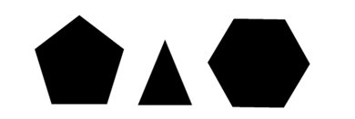
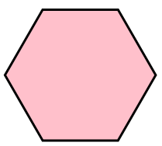
- Try to tessellate a regular hexagon. Explain why it does or does not work.
- Will a scalene triangle tessellate? Draw one and try it.
What about an isosceles triangle?
- Raymond is designing a stained glass window. He wants to tile it with only quadrilaterals. Which of Raymond’s quadrilaterals tessellate? Explain how you know. 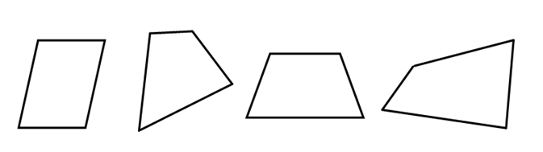

Building Block: Students can identify a translation, reflection or rotation (or a combination of) in a given tessellation (including tessellations in the environment)
- Math Makes Sense: the textbook is a great resource to find example questions that can be used with students. Below are some examples to get you started:
  - Math Makes Sense 8, pages 176: 476-478
- Describe the transformation(s) that was used to create these tessellations.
  - b.
- What transformation was needed to tessellate shape A to position B?
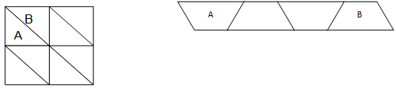

- Bella and Nicole are trying to figure out how this tessellation was made.
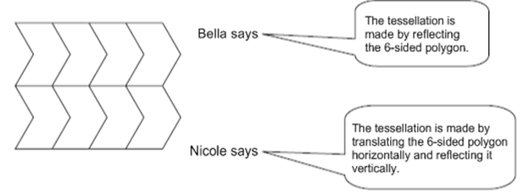
Demonstrate who is correct?

- Identify the translations, rotations and reflections for the shaded area in the following diagram that occurred to arrive at each figure (A, B, C and D). Explain how you know.
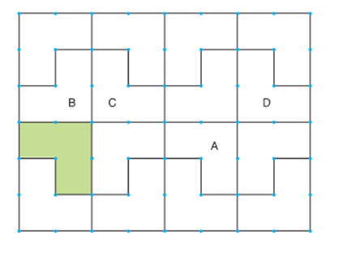
- Tessellate the following shape to fill the entire grid. Describe the transformations you performed to accomplish this task.
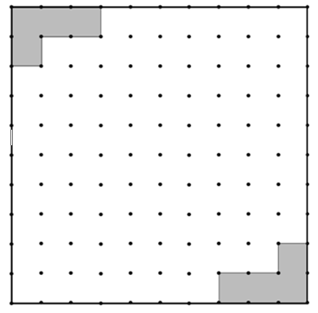
- Describe the following tessellations. What are they and how were they created?

- Show at least three possible tessellation patterns that can be made with the blue rhombus block.
Record the designs and show where there are translations, reflections and/or rotations.
Can more than one tessellating pattern be made with other pattern blocks, using only one shape in each design? Record and identify where there are translations, reflections and/or rotations.

Building Block: Students can create a tessellation using one or more 2-D shapes or by transforming an existing tessellation, and describe the tessellation in terms of transformations and conservation of area.
- Below are links to some websites that deal with tessalations.
  - http://illuminations.nctm.org/Activity.aspx?id=3533
  - http://www.maths2art.co.uk/tessellation.htm
  - https://www.youtube.com/watch?v=NYGIhZ_HWfg
  - http://gwydir.demon.co.uk/jo/tess/index.htm

