Greeting Small Frys!

We are starting Week 3 of Home Learning and all is going very well so far! We have spoken to a lot of you and your parents over the past 2 weeks and will continue to make home contact. We are also receiving lots of assignments and work from you and that is awesome. Remember, if anyone has questions or concerns about anything, you can communicate with us and each other at any time.
There are several ways we can communicate…
- Microsoft Teams – Mr. Nicol has our whole team set up and you can access it using your school e-mail
- Teacher Pages – Your weekly work will be posted here, including the Math as usual
- Teacher E-mails – cindy.fortune@nbed.nb.ca, Ginette.brewster@nbed.nb.ca, heather.campbell@nbed.nb.ca, David.good@nbed.nb.ca, Jason.nicol@nbed.nb.ca
There will be 4 pages posted on our Teacher Pages and our Small Frys Messenger Group that outlines your 3rd week in LA, French, Math and Science. Here is a Week 3 calendar that can help keep you organized and on track. When you finish any work on any day, you can submit it for feedback – you do not have to wait until the end of the week.

Grade 6 Weekly Home Learning Schedule- 1.5 hrs per day, .5 hrs Health, Wellness, Arts
Week 3 …4/20/2020 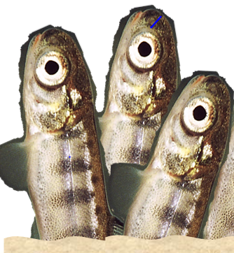
Monday  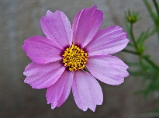 | - LA – all (30 min)  - Imm and PIF - Projet Capsule/  DuoLingo (30 min)  - Math (30 min)  - Health, Wellness, Arts (your choice)
Tuesday  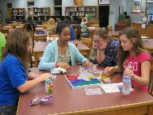 | - LA – PIF (30 min)  - Imm – Projet Capsule/ DuoLingo  (30 min)  - Math (30 min)  - Science (30 min)  - Health, Wellness, Arts (your choice)
Wednesday | - LA- all (30 min)  - Imm and PIF - Projet Capsule/  DuoLingo (30 min)  - Math (30 min)  - Health, Wellness, Arts (your choice)
Thursday  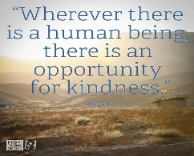 | - LA- PIF (30 min)  - Imm – Projet Capsule/DuoLingo  (30 min)  - Math (30 min)  - Science (30 mins)  - Health, Wellness, Arts (your choice)
Friday | - LA Writing -all (30 min)  - Science (30 min)  - Math (30 min)  - Share what you accomplished this week!  HAVE A WONDERFUL WEEKEND!

Health, Wellness, Arts
You can decide what you’d like to do with this, and maybe drop us a short blurb (text) or video at the end of the week. This way we can share our achievements!
Some suggested activities (but, again, you can decide and be creative) …

Art- Art Journal Entry #1- Sunshine, Symmetry and Scale- Combine these Art Elements and add some sunshine! An example of this journal entry is on my Teacher page and my Twitter account @STUDIO628. (- Mrs. Nicol)
Physical Activity – You can keep a journal or check list or take a video of any physical activity you did throughout the week: exercises, piling wood, walking your pets, doing yoga, cleaning the bathroom…
Music – You can record/video yourself playing a musical instrument or singing or lip syncing playing an air guitar…
Reading – You can show us a good book you are reading and/or record yourself reading an excerpt from it…
School- Wide STEM Challenge- if anyone is interested, you can find details on our SMS website.

IMPORTANT NOTE from Mrs. Chaisson:
Hello SMS students!

I hope everyone is keeping healthy, both physically and mentally. I know that some of us may be feeling down or frustrated these days! If you feel that you need help managing or have questions or concerns about our current situation, please feel free to e-mail me! I will also be updating my teacher page on the SMS website. This will include websites to get real information, mental and physical health tips, phone numbers and websites where you can access counselling. Remember, your SMS family is thinking about all of you!

Mrs. Chaisson - Nicole.chaisson@nbed.nb.ca

