Name:______________________ SS1, SS2, SS3, SS4, SS5 – Review Assignment
1. Name each triangle in 2 different ways.
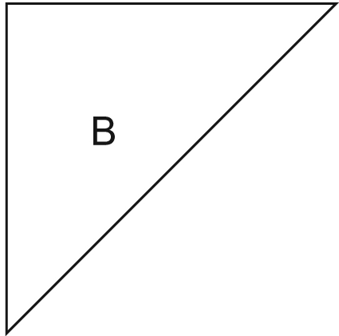
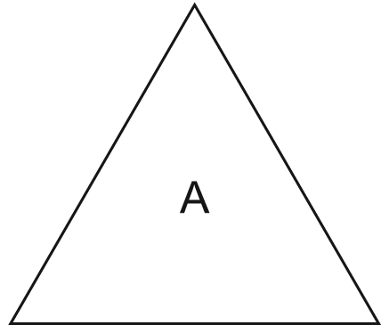

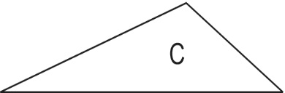

_______________ _______________ _______________
_______________ _______________ _______________
2. Use a ruler and protractor.
a) Draw triangle ABC.  ∠B is 30°°.  Side AB is 5 cm. Side BC is 3cm. | b) Draw triangle XYZ.  ∠X is 60°.  ∠Y is 50°.  Side XY is 5 cm.

3. Use a formula to find the perimeter of the shape below.
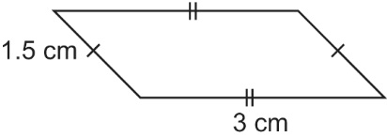

4. Complete the table below.
Rectangle | Length  (cm) | Width  (cm) | Area  (cm²)
A | 14 | 6
B | 25 |  | 300
C |  | 8 | 128
D | 11.5 | 9

6. Which pairs of polygons are congruent? How did you decide?
________________________________________________________________
________________________________________________________________

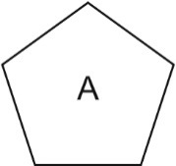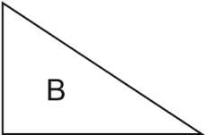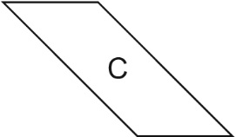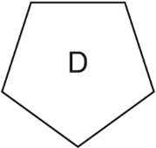

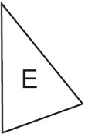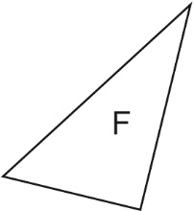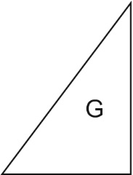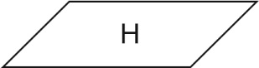

7. A quadrilateral has three angles that measure 70°, 125°, and 35°. A student says the measure of the fourth angle is 120°. Is the student correct? Explain how you know.

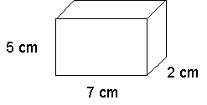
8. Find the volume of the rectangular prism.
________________________
________________________
________________________

9. Sort the polygons into sets of regular and irregular polygons.
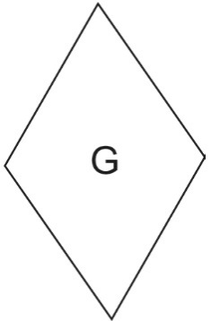
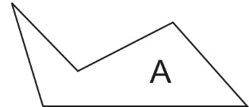 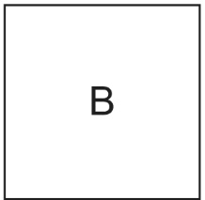 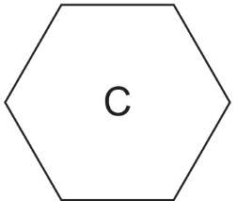 regular irregular
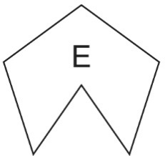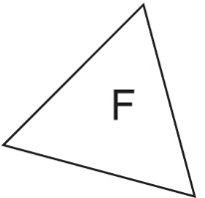

Multiple Choice Questions
- Which angle is greater than 90º ?
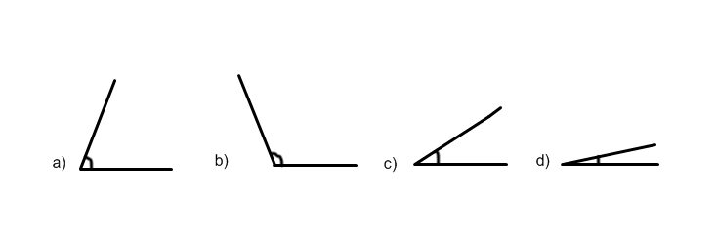
- What is the measurement of the missing angle?
30 º
110 º

- 30 º b) 35 º c) 40 º d)45 º

- What are the measurements of the missing angles?

80 º
80 º

?

?

- 100º & 80 º b) 80 º & 100 º c) 95 º & 95 º d) 100 º & 100 º

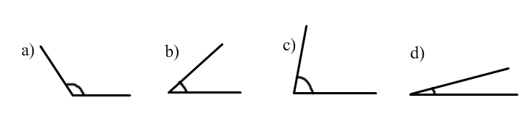
- Which of these angles measures approximately 45 ͦ ?

- Which of the following angles is obtuse?

- Which of the following angle is a reflex angle? 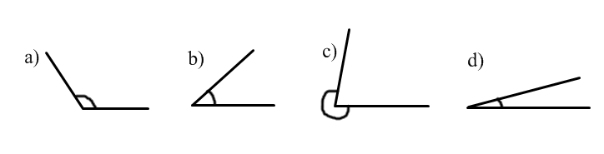

7. Which of the following is real-life example of a right angle?

a) The corner of your math text book
b) A 5-sided star on top of a Christmas tree
c) A wheel of a car
d) A stop sign

8. Which of the following triangles in a right angle triangle? 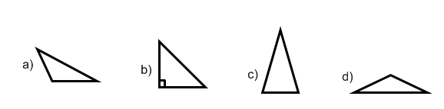
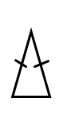
9. The following triangle can be classified as a:
a) acute and right angle triangle
b) obtuse and isosceles triangle
c) right and isosceles triangle
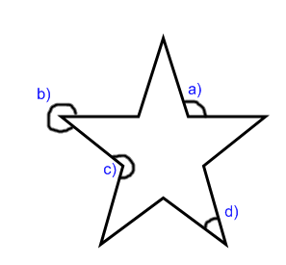
d) acute and isosceles triangle

10 . In the following shape, which angle is acute?

Bonus question: A rectangular garden has perimeter 36 m.
Draw 3 different rectangles with perimeter 36 m named A, B, C.
What is the area for each of the rectangle that you drew?_A_________ B _________ C_________

