Lesson 10 A Check-Up
Lesson 10 A: Perimeters of Polygons
SS4
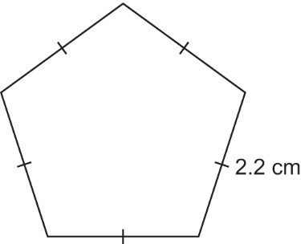
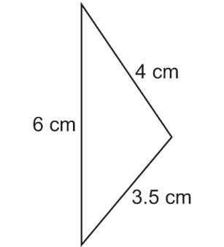
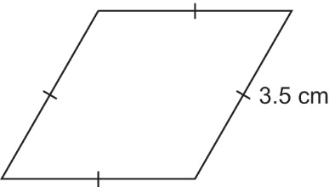
1. Find the perimeter of each polygon.
a) b) c)

2. The perimeter of an isosceles triangle is 24 cm.
What might the lengths of the sides be?
Give 3 different answers.

3. Write the side length of each polygon.

a) a regular hexagon with perimeter 18 m

b) a regular pentagon with perimeter 25 cm

c) an equilateral triangle with perimeter 36 cm

4. Find the perimeter of each polygon.

a) a regular octagon with side length 7 cm

b) a pentagon with side lengths 4 cm, 6 cm, 4 cm, 5 cm, 5 cm

c) a parallelogram with side lengths 6 m and 12 m

Lesson 10 B Check-Up
Lesson 10 B: Area of a Rectangle
SS4
1. Which rectangle has the greatest area?
How do you know?
a) Rectangle A: length 20 cm and width 5 cm

b) Rectangle B: length 13 cm and width 12 cm

c) Rectangle C: length 36 cm and width 9 cm

2. The perimeter of a rectangle is 30 cm.
Find the whole-number dimensions of the rectangle with:
a) the greatest area

b) the least area

3. Complete this chart.
Rectangle | Length (m) | Width (m) | Area (m²)
A | 9 | 11
B | 15 |  | 60
C |  | 3 | 48
D | 6 |  | 33
E | 7.8 | 6

4. Rectangle A has area 70 cm² and width 5 cm.
Rectangle B has one-half the area of Rectangle A.
The rectangles have the same width.
What is the length of Rectangle B?

Lesson 10 C Check-Up
Lesson 10 C: Volume of a Rectangular Prism
SS4
1. Find the volume of each rectangular prism.

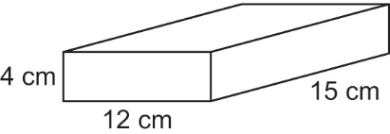
a)

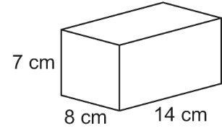
b)

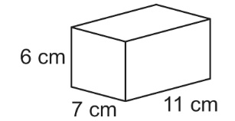
c)

2. A box is 5 m long, 1.5 m wide, and 2 m tall.
What is the volume of the box?

3. Find the volume of each rectangular prism.
Use a calculator when you need to.

Rectangular Prism | Length (cm) | Width (cm) | Height (cm)
A | 18 | 9 | 12
B | 20 | 15 | 8
C | 5.6 | 4 | 6
D | 9 | 8 | 10

