- There are no check ups throughout these outcomes (only an End Assessment) so it is important that you watch all learning videos carefully and play the games suggested: do not skip anything

SS8 Learning Outcomes:
- Label the axes of the first quadrant of a Cartesian plane and identify the origin.
- Plot a point in the first quadrant of a Cartesian plane given its ordered pair.
- Match points in the first quadrant of a Cartesian plane with their corresponding ordered pair.
- Plot points in the first quadrant of a Cartesian plane with intervals of 1, 2, 5, or 10 on its axes, given whole number ordered pairs.
- Draw shapes or designs in the first quadrant of a Cartesian plane, using given ordered pairs.
- Determine the distance between points along horizontal and vertical lines in the first quadrant of a Cartesian plane.
- Draw shapes or designs in the first quadrant of a Cartesian plane and identify the points used to produce them.

Videos :
http://studyjams.scholastic.com/studyjams/jams/math/algebra/ordered-pairs.htm
Brainpop.com- you can watch the video then explore the other resources on this website
Login name : SmallFrys Password: Grade6
https://www.brainpop.com/math/algebra/graphinglinearequations/

Games :
https://www.mathsisfun.com/data/click-coordinate.html
http://www.mathgametime.com/games/battleship
https://www.mathsisfun.com/data/cartesian-coordinates-interactive.html
https://www.brainpop.com/games/gameovergopher/
Song :
https://youtu.be/d6vhjpnfd3c
Activities :
https://www.mathsisfun.com/diplodocus.html
https://www.mathsisfun.com/coordinate_alien.html

Advanced Activities (Take it Further):
Miss Piggy
As you connect the dots, instead of using straight lines, it is better to round off as you go – Miss Piggy is definitely more round than square…

Shape 1
(-1, 9), (-1, 13), (0, 13), (0, 14), (3, 14), (3, 13), (4, 13), (4, 9), (3, 9), (3, 12), (2, 12), (2, 13),
(1, 13), (1, 12), (0, 12), (0, 9), (-1, 9)

Shape 2
Draw line from (0, 9) to (3, 9)

Shape 3
(8, 6), (8, 8), (13, 8), (13, 7), (14, 7), (14, 4), (13, 4), (13, 3), (11, 3), (11, 4), (12, 4), (12, 5),
(13, 5), (13, 6), (12, 6), (12, 7), (9, 7), (9, 6), (8, 6)

Shape 4
(8, 6), (8,5), (9, 5), (9, 4), (10, 4), (10, 3), (11,3)

Shape 5
(-13, 0), (-13, 1), (-12, 1), (-12, 3), (-10, 3), (-10, 4), (-8, 4), (-8, 5), (-6, 5), (-6, 6), (-5, 6), (-5, 7) (-4, 7), (-4, 8), (-1, 8), (-1, 9), (5, 9), (5, 8), (6, 8), (6, 7), (7, 7), (7, 6), (8, 6), (8, 5), (9, 5), (9, 4), (10, 4), (10, 3), (11, 3), (11, -1), (10, -1), (10, -4), (11, -4), (11, -6), (12, -6), (12, -8), (13, -8),
(13, -10), (14, -10), (14, -13), (13, -13), (13, -14), (12, -14), (12, -15), (8, -15), (8, -11), (7, -11), (7, 2), (5, 2), (5, 4), (3, 4), (3, 5), (-1, 5), (-1, 4), (-3, 4), (-3, 3), (-5, 3), (-5, 1), (-6, 1), (-6, 0),
(-7, 0), (-7, -2), (-8, -2), (-8, -5), (-7, -5), (-7, -10), (-8, -10), (-8, -11), (-9, -11), (-9, -12),
(-10, -12), (-10, -13), (-12, -13), (-12, -10), (-11, -10), (-11, -3), (-12, -3), (-12, -2), (-13, -2),
(-13, 0)

Shape 6
(-3, -2), (0, -2), (0, -3), (1, -3), (1, -4), (2, -4), (2, -6), (1, -6), (1, -7), (-1, -7), (-4, -7), (-4, -3),
(-3, -3), (-3, -2)

Shape 7
(-3, -4), (-2, -4), (-2, -5), (-3, -5), (-3, -4)

Shape 8
(-1, -5), (0, -5), (0, -6), (-1, -6), (-1, -5)

Shape 9
(-9, -12), (-8, -12), (-8, -14), (-6, -14), (-6, -13), (-5, -13), (-5, -12), (-2, -12), (-2, -11), (-1, -11),
(-1, 10), (7, 10)

Shape 10
(-3, 3), (2, 3), (2, 2), (0, 2), (0, 1), (-1, 1), (-1, 2), (-3, 2), (-3, 3)
Fill this shape in black

Shape 11
(3, 0), (3, 1), (5, 1), (5, 0), (6, 0), (6, -3), (5, -3), (5, -1), (4, -1), (4, 0), (3, 0)
Fill this shape in black
Shape 12
(-2, 2), (-1, 2), (-1, 1), (0, 1), (0, 2), (1, 2), (1, 1), (0, 1), (0, 0), (-1, 0), (-1, 1), (-2, 1), (-2, 2)
Fill in this shape her eye color (light or bright blue, green, brown, etc.)

Shape 13
(3, 0), (4, 0), (4, -1), (5, -1), (5, -2), (3, -2), (3, 0)
Fill in this shape her eye color (light or bright blue, green, brown, etc.)

Shape 14
(-3, 4), (1, 4), (1, 3), (-3, 3), (-3, 4)
This is eye shadow – color it a bright color not used elsewhere

Shape 15
(4, 2), (5, 2), (5, 1), (6, 1), (6, 0), (7, 0), (7, -1), (6, -1), (6, 0), (5, 0), (5, 1), (4, 1), (4, 2)
This is eye shadow – color it a bright color not used elsewhere

Shape 16
(-4, -7), (-1, -7), (-1, -8), (-2, -8), (-2, -9), (-3, -9), (-3, -8), (-4, -8), (-4, -7)
Color her lipstick brown, dark or bright red, bright pink, or a blend of colors

Shape 17
(8, -15), (7, -15), (7, -14), (6, -14), (6, -12), (5, -12), (5, -11), (1, -11), (1, -12), (-1, -12), (-1, -13), (-2, -13), (-2, -14), (-1, -14), (-1, -15), (-10, -15), (-10, -12), (-9, -12)
Color her dress whatever color you want – maybe same color as eye shadow…

Color face and outer ears apricot, light peach or light pink
Color inner ears and nose orange, peach, or medium to dark pink
Color inside holes of her nose either black or darker version of same color as outer ears
Color hair yellow (or whatever color you would like…)

Shape 18
(-11, -13), (-10, -13), (-10, -15), (11, -15), (-11, -13)
One of her arms – color same color as face and outer ears

Shape 19
Draw line from (-1, -15) to (7, -15)
Her other arm – color same color as face, outer ears, and other arm

Have fun with the art work!

Key
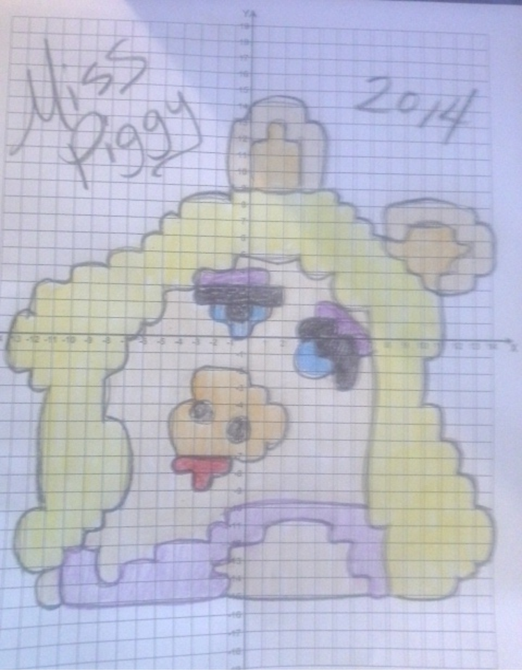

SS9 Learning Outcomes:

□ Identify the 3 types of transformations on a Cartesian plane.
□ Perform 3 types of transformations on a Cartesian plane.
□ Identify the coordinates of the new image
□ Describe the change from the old to the new image

Learning videos…
https://www.youtube.com/watch?v=XdjH_EWhCZ0
https://www.youtube.com/watch?v=5OWPuFUyIt8
https://www.youtube.com/watch?v=LifhWhHVXJ0

Games…
https://nl.mathgames.com/skill/7.90-identify-reflections-rotations-and-translations
https://www.mathplayground.com/TransformationWorkshop/index.html
https://www.mathplayground.com/ShapeMods/index.html

End Assessment (3 tasks…)

- Draw a picture in the first quadrant of the Cartesian plane and identify the points used to produce them (minimum of 10 ordered pairs) – take a pic and send it to us

- Show how you know if a figure and its image shows a reflection, translation or rotation. (This can be shown anyway you want: words, pictures, make a video to explain…)

- Mystery Graph- plot these coordinates. Connect each pair in order. What is this picture?

6, 16
7, 16
7, 15
STOP
14, 7
14, 4
15, 3
15, 2
12, 2
STOP
6, 4
7, 3
6, 2
2, 2
1, 3
3, 5
5, 5
6, 4
8, 3
8, 1
7, 0
1, 0
0, 1
0, 3
2, 4
STOP
12, 6
12, 2
9, 2
9, 3
10, 4
10, 7
9, 8
9, 9
STOP
2, 15
3, 16
2, 16
2, 13
3, 12
5, 12
6, 11
4, 9
6, 9
7, 10
8, 10
9, 9
11, 11
10, 12
8, 10
STOP
11, 11
12, 12
15, 12
16, 11
17, 14
14, 18
13, 18
12, 19
15, 19
18, 15
18, 13

17, 10
17, 8
16, 7
16, 5
17, 4
17, 3
15, 3
STOP
3, 16
4, 16
5, 15
6, 17
5, 18
4, 18
3, 20
6, 20
8, 17
8, 16
10, 16
10, 17
9, 17
8, 19
11, 19
12, 16
10, 14
10, 12
STOP
Put a small circle at (6, 15)

