Flap Flop

- Take the folded paper and draw full scene picture across the folded flap. BUT draw half of a person’s face on the paper and the other half on the flap.
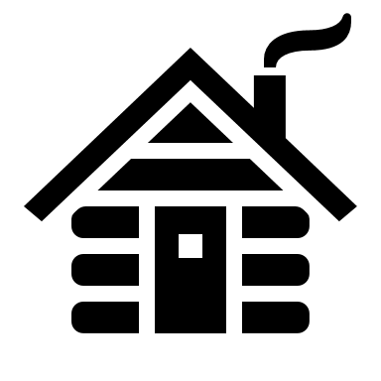

- Open the flap and complete the picture there, too. This time ,however, make a huge change to the picture.
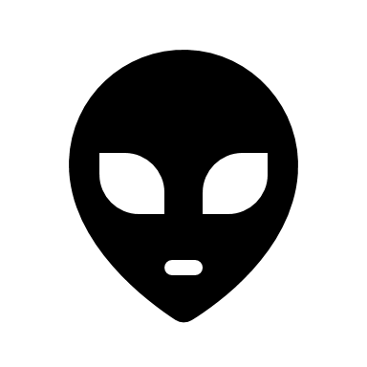

- When you are happy with you have created inside the flap, colour in your picture, including both sides of the flap using lots of colour!

