Wednesday, November 3, 2021
Salutations Super Sixes!
Below are the access areas for your assigned work. Choose the site you are most comfortable using.
(1) Teacher Pages – Your work will be posted here, including the Math as usual
http://superiormiddleschool.nbed.nb.ca/teacher/grade-6
(2) Your email – Many of the assignments and letters have been sent to your school nbss account. You can access your email by going to google and typing in the address bar - portal.office.com
(3) Teacher E-mails – sandra.cleland@nbed.nb.ca , heather.campbell@nbed.nb.ca , patrick.vienneau@nbed.nb.ca , penny.roy@nbed.nb.ca , renee.kenny@nbed.nb.ca
(4) Class DOJO – For family updates
6-1/6-2 : https://www.classdojo.com/invite/?c=CKFTKWZ
6-3/6-4: https://www.classdojo.com/invite/?c=CWC2KQK
Grade 6 Daily Home Learning Schedule – 1.5 hrs per day, .5 hrs Health, Wellness or Art

Wednesday – November 3, 2021
- Language Arts
(All students) Complete any incomplete work from Monday or Tuesday

- FILA Complete any incomplete work from Monday or Tuesday.

- Math:
Mrs. Cleland – Continue outcome PR1 – PowerPoint (Teacher Pages), Journal question (see below) and handout (Step By Step 1). Study Ladder- username and passwords sent to student email account.

Mme Campbell & Mme Penny – Continue PR1 – Powerpoint (Teacher Pages), Journal question and handout (Step By Step 1) (see below).

Mr. Vienneau – Study Ladder website

Mme Kenny – Continue IXL
(A digital copy of “Math Makes Sense” is available on Teacher Pages)
- Physical Education / Health: Please see below

- Art with Mrs. Kenny - See TEAMS

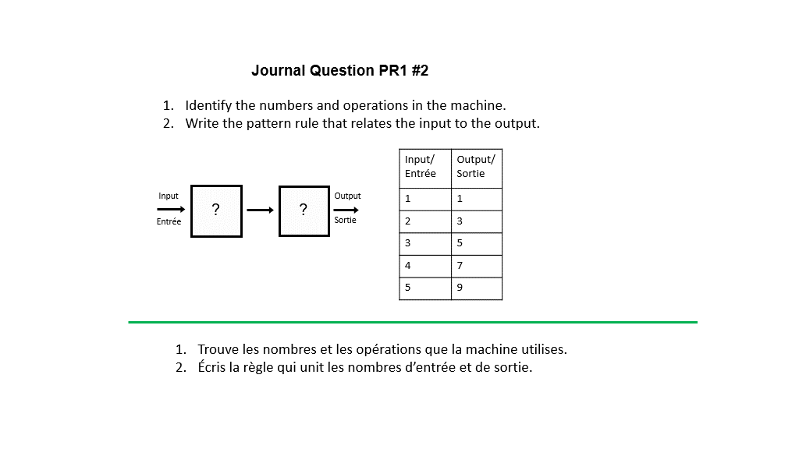

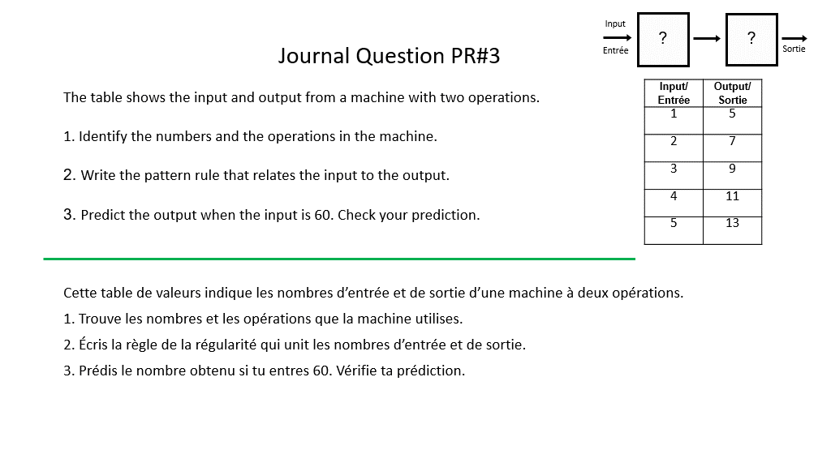

Math: Use the table (below) to answer the Step-By-Step 1 questions. It is on p.9 of the Math textbook.
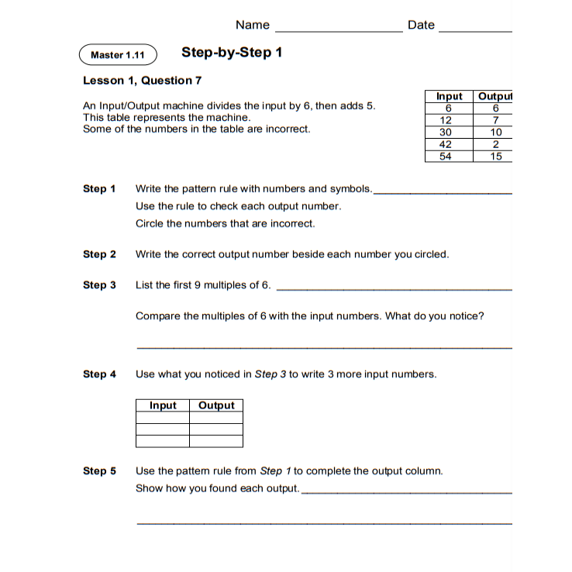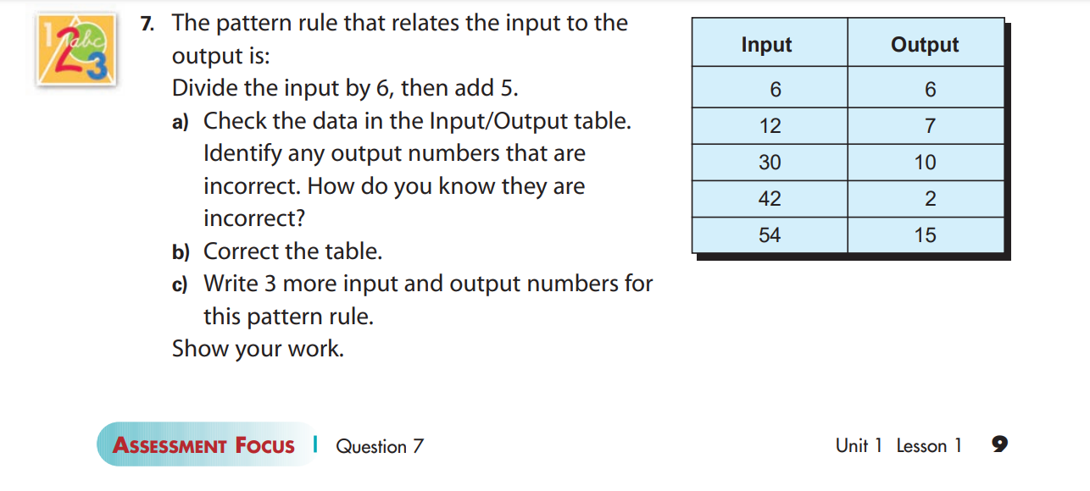

Phys. Ed challenge of the day:
Check-off or write how many you were able to do in the space next to the challenge.
Stations
1. Crunches – perform as many crunches as possible in 30 seconds
2. Jumping Jacks – perform as many jumping jacks as possible in 30 seconds
3. Wall Sit – perform a wall sit for 30 seconds
4. Air Squats – perform as many air squats in 30 seconds aspossible.
5. Skipping – jump rope for 30 seconds
6. Plank – hold the plank position for 30 seconds.
7. Sprints – sprint your backyard or driveway up and down as many times as you can in 30 seconds. (Don’t get too close to the road)
8. Burpees – perform as many burpees as possible in 30 seconds.
9. Stork Stand –Perform a stork stand for 30 seconds, 15 seconds on each leg.

