Here are some challenges for Phys Ed this week. We will have a Teams meeting on Friday for a fun challenge. Stay healthy!

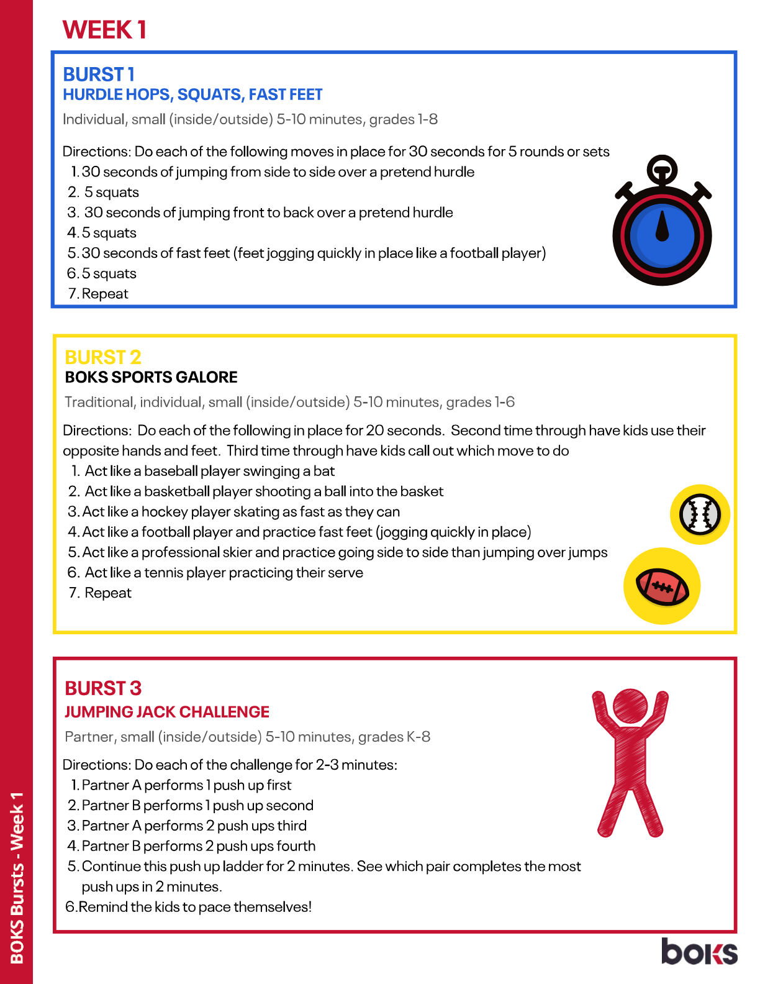

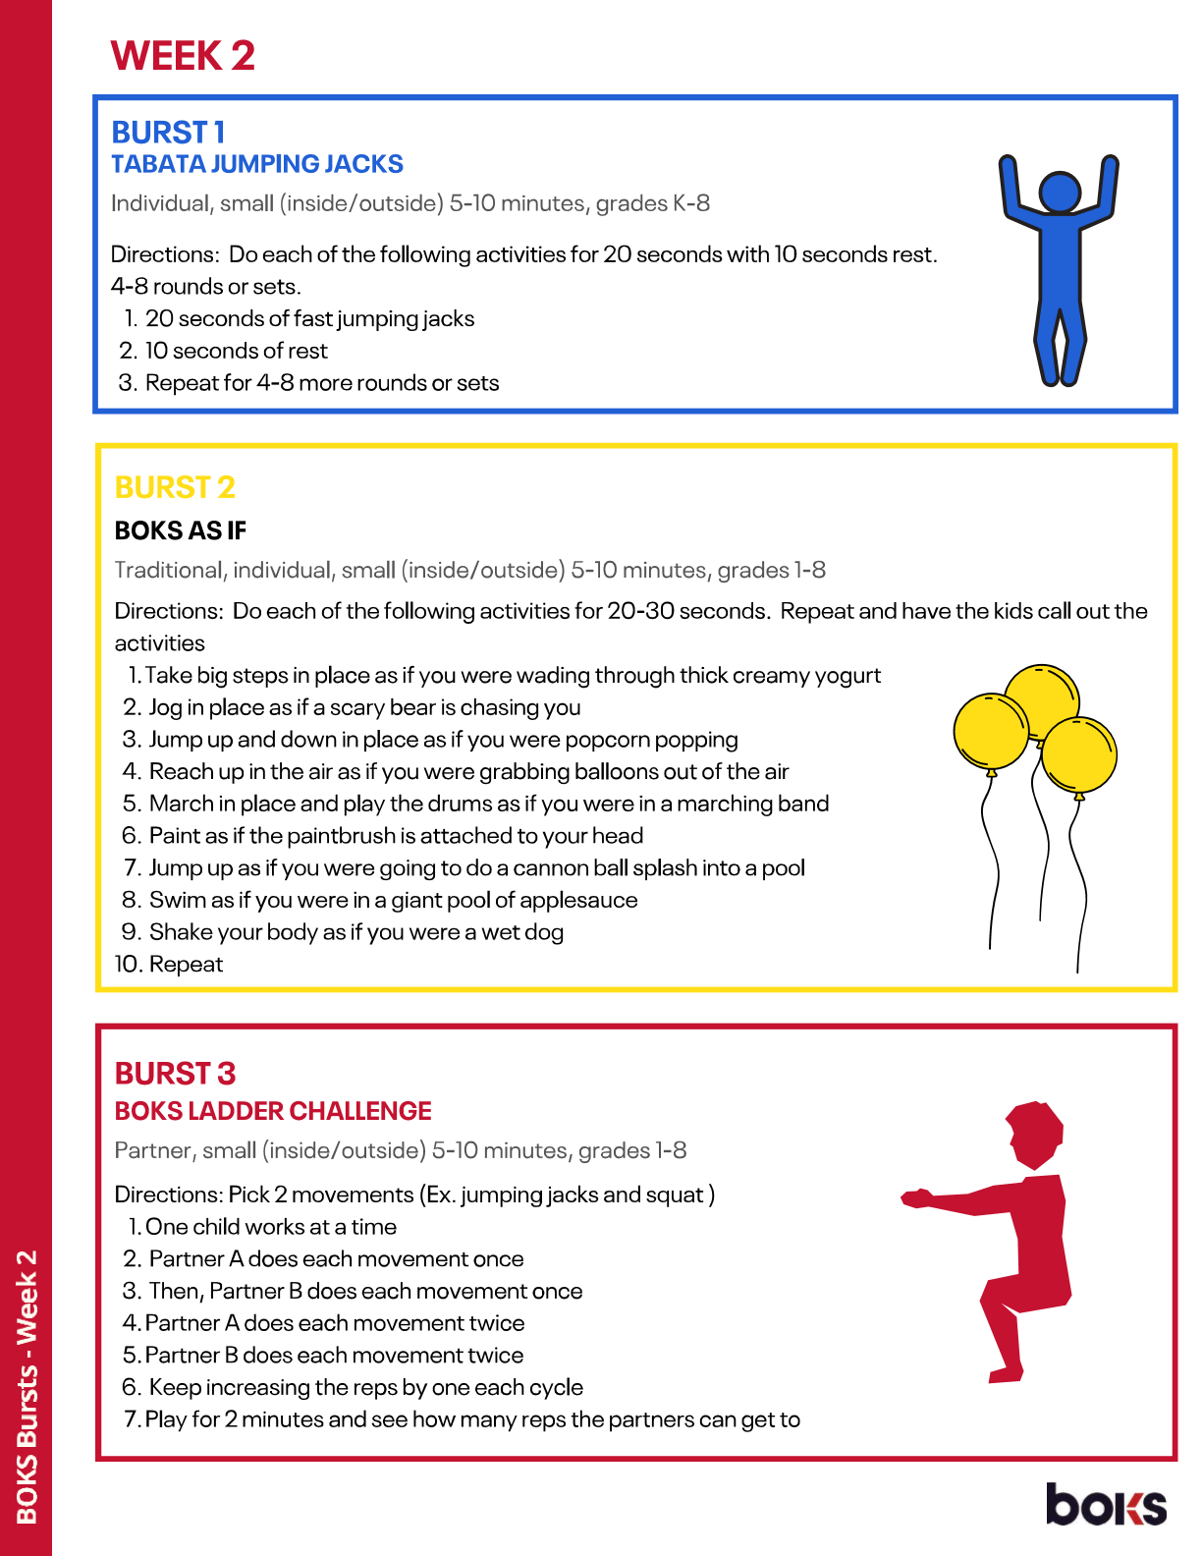

Post-Intensive French : You can access free French class via this website: www.duolingo.com/classroom/gqcmey
Most of you did your own account already. If you have any problems, please contact me via e-mail or Teams.

You can access free french books with this link : https://jelis.rkpublishing.com/student/
Your login ID is the first 3 letters of your name and the first 3 letters of your last name.
Ex: Cristiano Ronaldo
Login id : criron
Password for every student : pv123

