POLICE WEEK
May 14 - 20, 2023
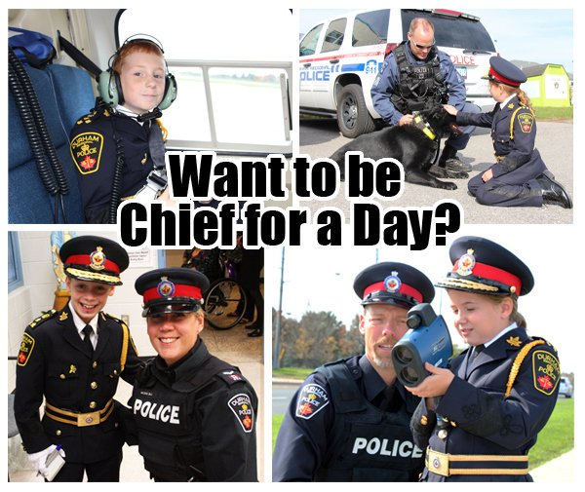
CONTEST

Here is how to enter:
Send us a short 30 second video or a message detailing the reasons you should be awarded the position of “CHIEF FOR A DAY” and why you think policing is important. You can use a few ideas below to help you out….
- Any involvement you had/have that made a difference in your community
- “Pay it forward” gesture you did
- Initiated an anti-bullying program in your classroom
- Random act of kindness
- Positive initiative at home/school
You can send your videos to our face book messenger at https://www.facebook.com/bathurstpoliceforce/

All participant’s names will be placed in a draw to become “Chief for a Day”

Deadline for submission is: Monday, May 1st
Draw will take place: May 1st. School will be contact and announced on FB.

Monday: May 14th
Pick up: At school at 9:00 and drop off at 3:00

Contact: Anne Marie Russell at 548-0524 or e-mail me at anne.godin@nbpolice.ca

Thank you for participating and good luck to all students!!!

