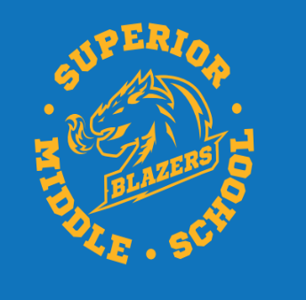
Dear SMS Parents/Guardians,
Superior Middle School
560 Duke Street
Bathurst, NB
E2A 2X5
Tel: (506)547-2750
Fax: (506)547-2784
http://superiormiddleschool.nbed.nb.ca/
https://www.facebook.com/superiormiddleschool

As previously stated, the official SMS Operational plan for our building will be released on Wednesday September 3rd, 2020. Until that time we can share some information that will be important for Students regarding our start-up here at SMS.

- There will be no 2pm bus run for students this year with the exception of students from Downshore. Students will still have the option of staying for our 2-3 program (activities) that will be offered in their bubble. If a student is being driven by a parent, they will have the option of leaving at 2:08 before our activities happens. All students will be dismissed through the student (gym) entrance.
- There will be no bus passes given throughout the year. Students will only be granted 1 pick-up and drop-off area.
- Superior Middle School will still only have classes ½ days every Wednesday. Dismissal times will be similar to last year for busses and all pickups will be at 12:00 noon.
- Students should not be dropped off before 7:50 am. All students will enter the building using the student entrance (gym) and must be wearing a mask upon entry. Students will proceed to their bubble classroom and there will be supervision in their area until announcements at 8:15.
- All students must wear a community mask in common areas of the school but will not be required to wear one in their class bubble. If students cannot wear a mask because of medical reasons a medical note must be provided.
- SMS will begin the year with staggered starting times for each grade level, based on student bubbles.
  - Tuesday September 8th -Grade 6 students/All 7 late Immersion students.
  - Thursday September 10th - Grade 7 students
  - Friday September 11th - Grade 8 students
- As difficult as it may be, parents cannot accompany their child into the building. All access to the building by parents/guardians must be by appointment only.

Our staff is looking forward to working with you all this year!!

David Chaisson
Acting Principal – Superior Middle School

